Name: Ankita Agrawal

Sec: L

Roll No. – 03 (191500123)

**Cryptography & Network Security Lab (CSE-8082)**

1. Write a program to implement Additive Cipher (Z26) with the following conditions:

* Plaintext should be in lowercase.
* Ciphertext should be uppercase.
* Brute force attack.

Code:

import java.util.Scanner;

public class Main {

public static void main(String[] args) {

Scanner sc = new Scanner(System.in);

int i, j, l, k = 97, key = 0, flag = 0, index = 0, keyVal;

String pt;

char[] ct1 = new char[10];

char[] pt1 = new char[10];

char temp;

System.out.println("ENTER PLAIN TEXT");

pt = sc.next();

System.out.println("ENTER KEY VALUE :");

key = sc.nextInt();

for (i = 0; i < pt.length(); i++) {

for (j = 0; j < 26; j++) {

if (pt.charAt(i) == ' ') {

flag = 0;

break;

}

temp = (char) (j + k);

if (pt.charAt(i) == temp) {

flag = 1;

index = j;

break;

}

}

if (flag == 1) {

char c = (char) (((index + key) % 26) + 97);

ct1[i] = c;

}

}

System.out.println("ENCRYPTED DATA:");

for (i = 0; i < pt.length(); i++) {

System.out.print(ct1[i]);

}

System.out.println("\n" + "DECRYPTION OF DATA USING BRUTE-FORCE ATTACK :");

key = 1;

while (key <= 26) {

for (i = 0; i < pt.length(); i++) {

for (j = 0; j < 26; j++) {

if (ct1[i] == ' ') {

flag = 0;

break;

}

temp = (char) (j + k);

if (ct1[i] == temp) {

flag = 1;

index = j;

break;

}

}

keyVal = index - key;

if (flag == 1 & keyVal > 0) {

pt1[i] = (char) ((keyVal % 26) + 97);

} else if (flag == 1) {

pt1[i] = (char) ((26 + keyVal) + 97);

}

}

System.out.print("\n" + "DECRYPTED DATA:");

for (i = 0; i < pt.length(); i++) {

char a = (pt1[i]);

char upperCase = Character.toUpperCase(a);

System.out.print(upperCase);

}

key++;

}

}

}

ScreenShot:

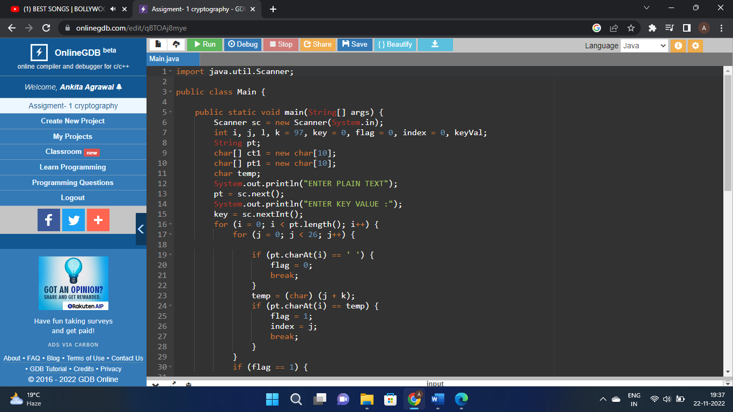

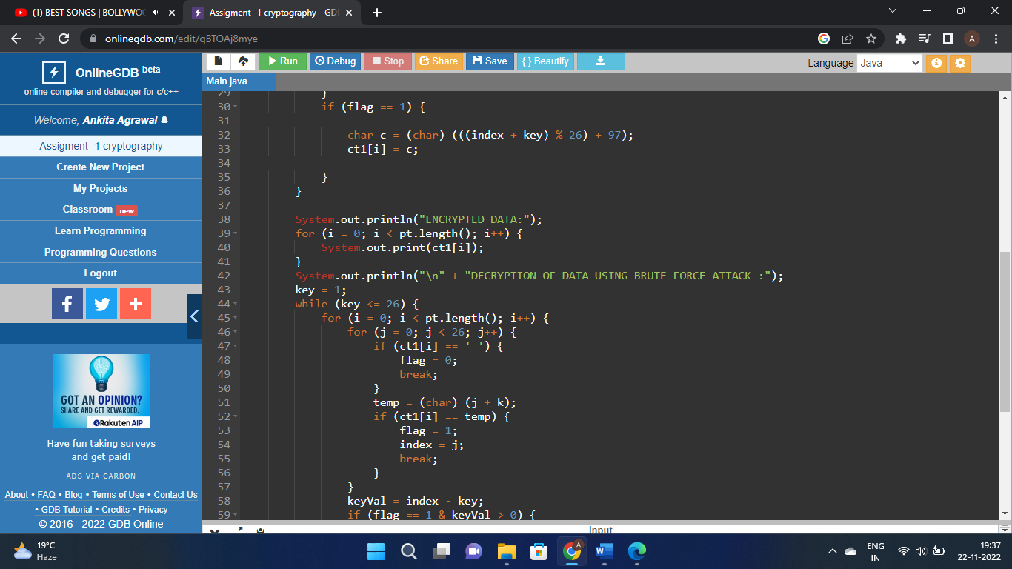

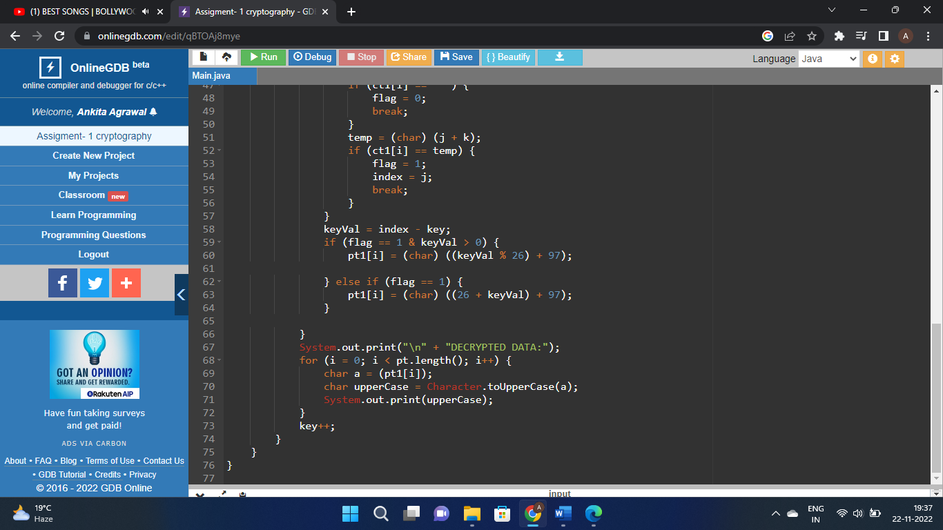

1. Write a program to implement a Multiplicative Cipher.
   * Plaintext should be in lowercase.
   * Ciphertext should be uppercase.
   * Brute force attack.

Code:

import java.util.*;

class Main

{

public static void main(String args[])

{

Scanner sc=new Scanner(System.in);

int shift,i,n;

String str;

String str1="";

String str2="";

System.out.println("Enter the plaintext");

str=sc.nextLine();

str=str.toLowerCase();

n=str.length();

char ch1[]=str.toCharArray();

char ch3;

char ch4;

System.out.println("Enter the value by which each letter of the string is to be shifted");

shift=sc.nextInt();

System.out.println();

System.out.println("Encrypted text is");

for(i=0;i<n;i++)

{

if(Character.isLetter(ch1[i]))

{

ch3=(char)(((int)ch1[i]*shift-97)%26+97);

str1=str1+ch3;

}

else if(ch1[i]==' ')

{

str1=str1+ch1[i];

}

}

System.out.println(str1);

int q=0,flag=0;

for(i=0;i<26;i++)

{

if(((i*26)+1)%shift==0)

{

q=((i*26)+1)/shift;

break;

}

}

System.out.println();

System.out.println("Decrypted text is");

char ch2[]=str1.toCharArray();

for(i=0;i<str1.length();i++)

{

if(Character.isLetter(ch2[i]))

{

ch4=(char)(((int)ch2[i]*q-97)%26+97);

str2=str2+ch4;

}

else if(ch2[i]==' ')

{

str2=str2+ch2[i];

}

}

System.out.println(str2);

}

}

ScreenShot:

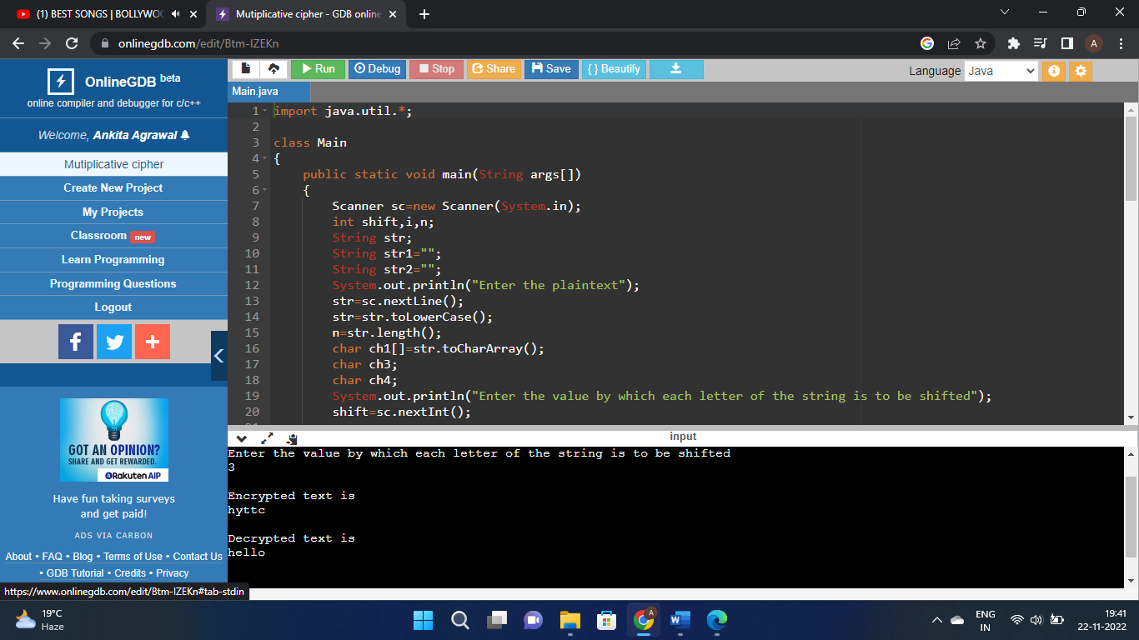

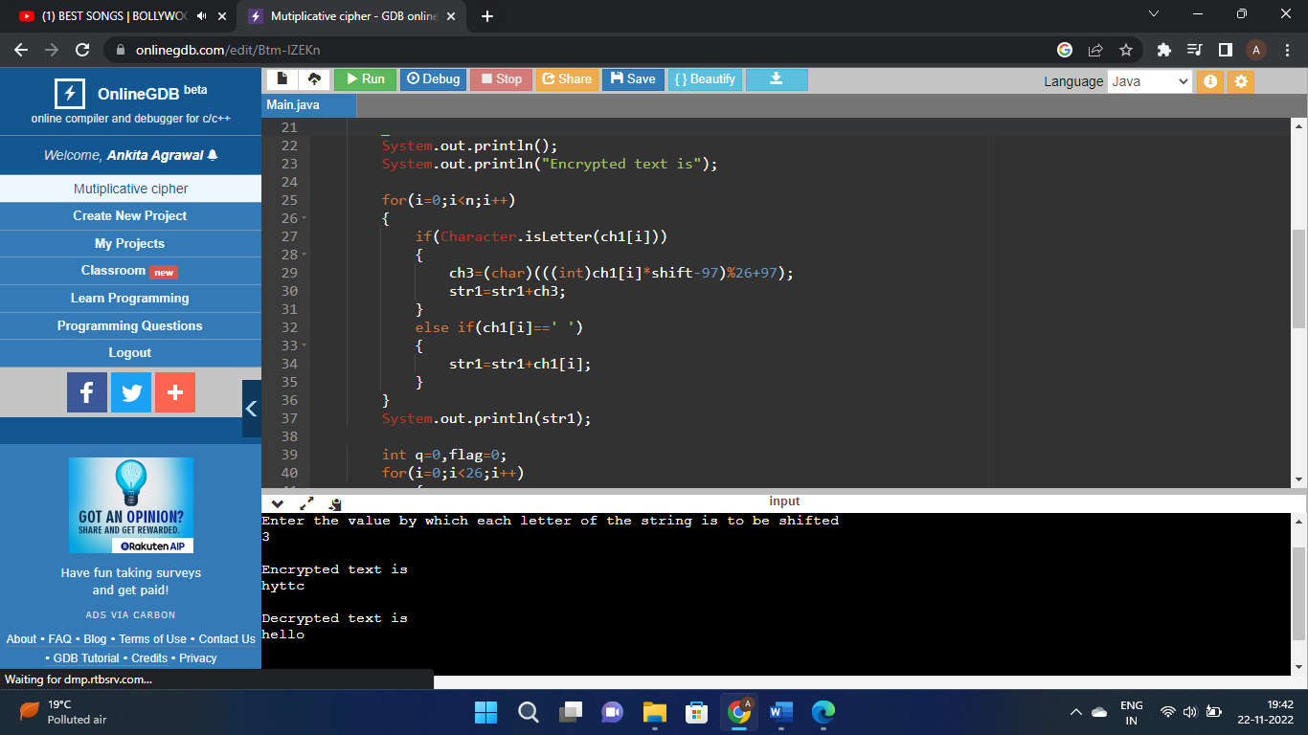

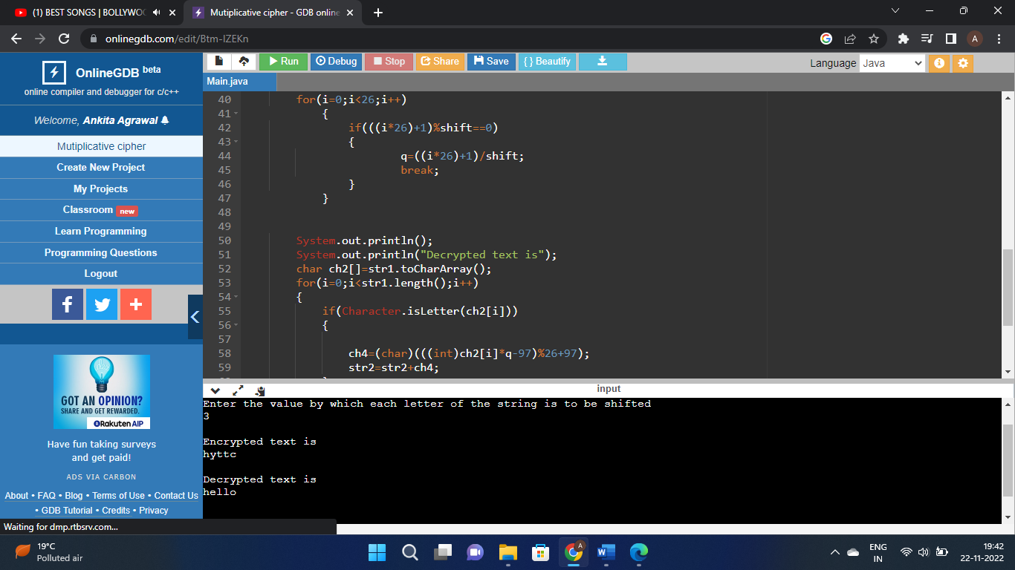

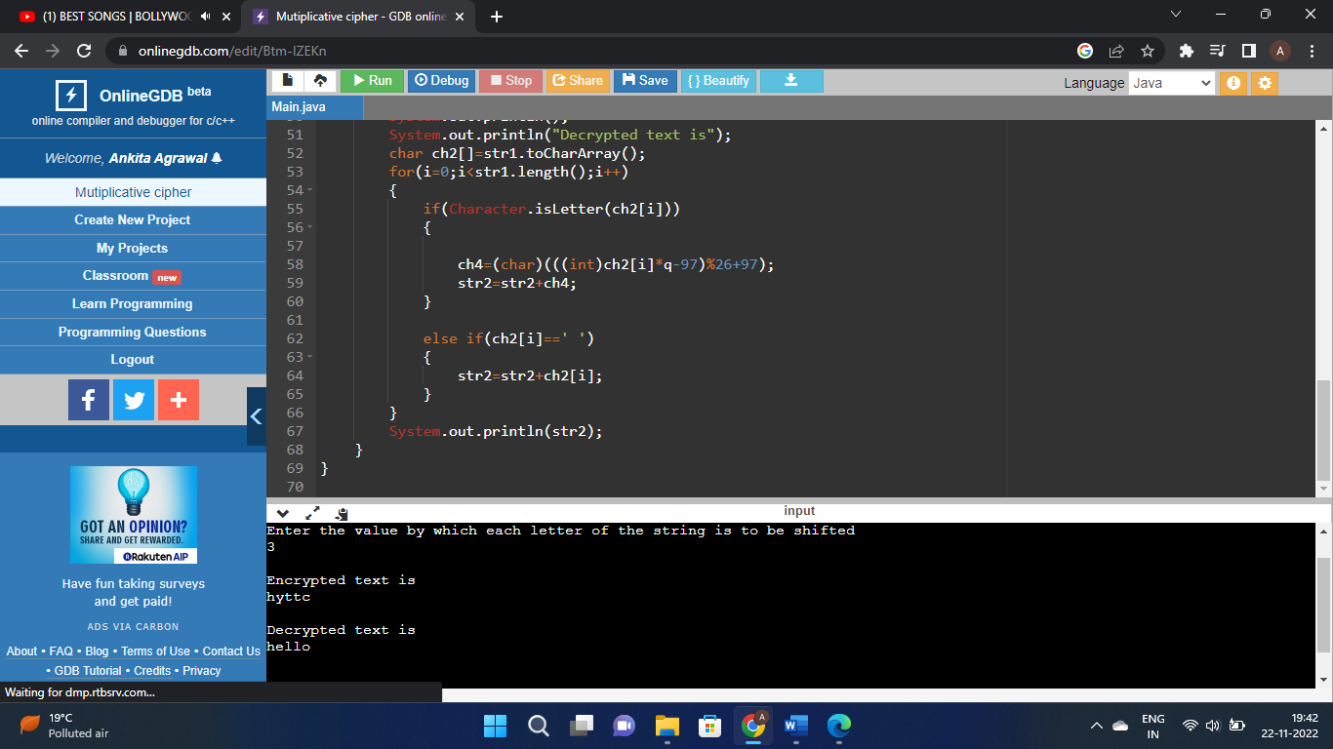

1. Write a program to implement Affine Cipher.

* Plaintext should be in lowercase.
* Ciphertext should be uppercase.
* Brute force attack.

Code:

class Main

{

static int a = 17;

static int b = 20;

static String Message(char[] msg)

{

String cipher = "";

for (int i = 0; i < msg.length; i++)

{

if (msg[i] != ' ')

{

cipher = cipher

+ (char) ((((a * (msg[i] - 'A')) + b) % 26) + 'A');

}

else

{

cipher += msg[i];

}

}

return cipher;

}

static String Cipher(String cipher)

{

String msg = "";

int a_inv = 0;

int flag = 0;

for (int i = 0; i < 26; i++)

{

flag = (a * i) % 26;

if (flag == 1)

{

a_inv = i;

}

}

for (int i = 0; i < cipher.length(); i++)

{

if (cipher.charAt(i) != ' ')

{

msg = msg + (char) (((a_inv *

((cipher.charAt(i) + 'A' - b)) % 26)) + 'A');

}

else

{

msg += cipher.charAt(i);

}

}

return msg;

}

public static void main(String[] args)

{

String msg = "CODE";

String cipherText = Message(msg.toCharArray());

System.out.println("Encrypted Message is : " + cipherText);

System.out.println("Decrypted Message is: " + Cipher(cipherText));

}

ScreenShot:

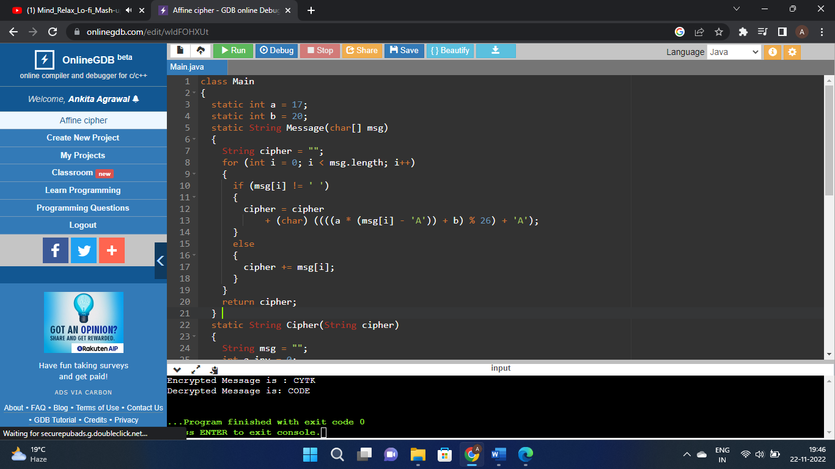

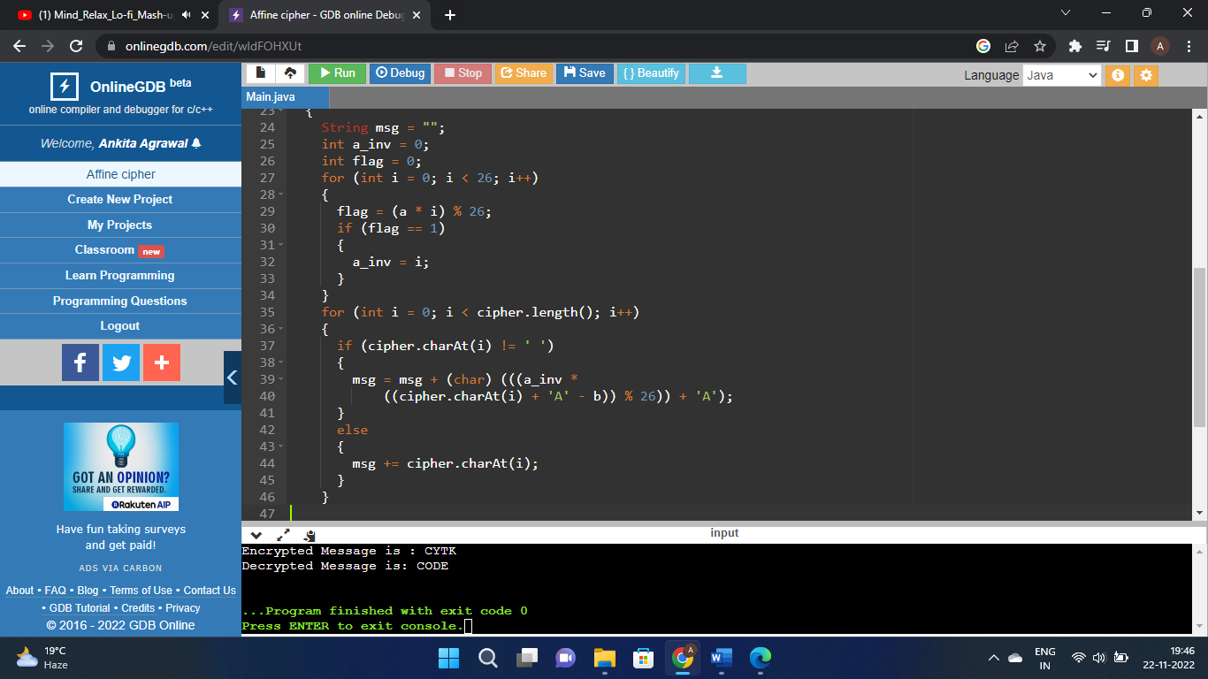

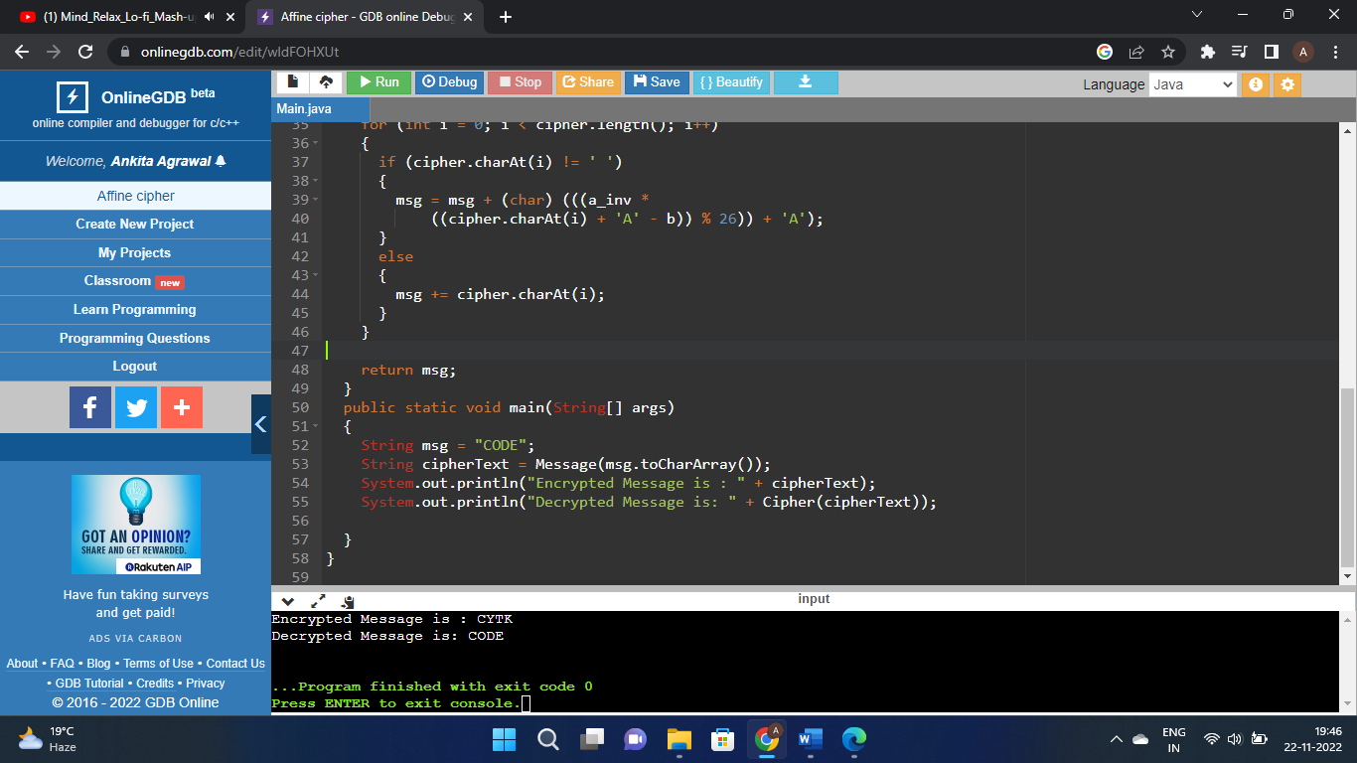

1. Write a program to implement Vignere Cipher

* Plaintext should be in lowercase.
* Ciphertext should be uppercase.
* Brute force attack.

Code:

#include <iostream>

using namespace std;

class Vigenere

{

public:

string key;

Vigenere(string key)

{

for (int i = 0; i < key.size(); ++i)

{

if (key[i] >= 'A' && key[i] <= 'Z')

this -> key += key[i];

else if (key[i] >= 'a' && key[i] <= 'z')

this -> key += key[i] + 'A' - 'a';

}

}

string encrypt(string text)

{

string out;

for (int i = 0, j = 0; i < text.length(); ++i)

{

char c = text[i];

if (c >= 'a' && c <= 'z')

c += 'A' - 'a';

else if (c < 'A' || c > 'Z')

continue;

out += (c + key[j] - 2 * 'A') % 26 + 'A';

j = (j + 1) % key.length();

}

return out;

}

string decrypt(string text)

{

string out;

for (int i = 0, j = 0; i < text.length(); ++i)

{

char c = text[i];

if (c >= 'a' && c <= 'z')

c += 'A' - 'a';

else if (c < 'A' || c > 'Z')

continue;

out += (c - key[j] + 26) % 26 + 'A';

j = (j + 1) % key.length();

}

return out;

}

};

int main()

{

Vigenere cipher("VIGENERECIPHER");

string original = "I AM INDIAN";

string encrypted = cipher.encrypt(original);

string decrypted = cipher.decrypt(encrypted);

cout << original << endl;

cout << "Encrypted: " << encrypted << endl;

cout << "Decrypted: " << decrypted << endl;

return 0;

}

ScreenShot:

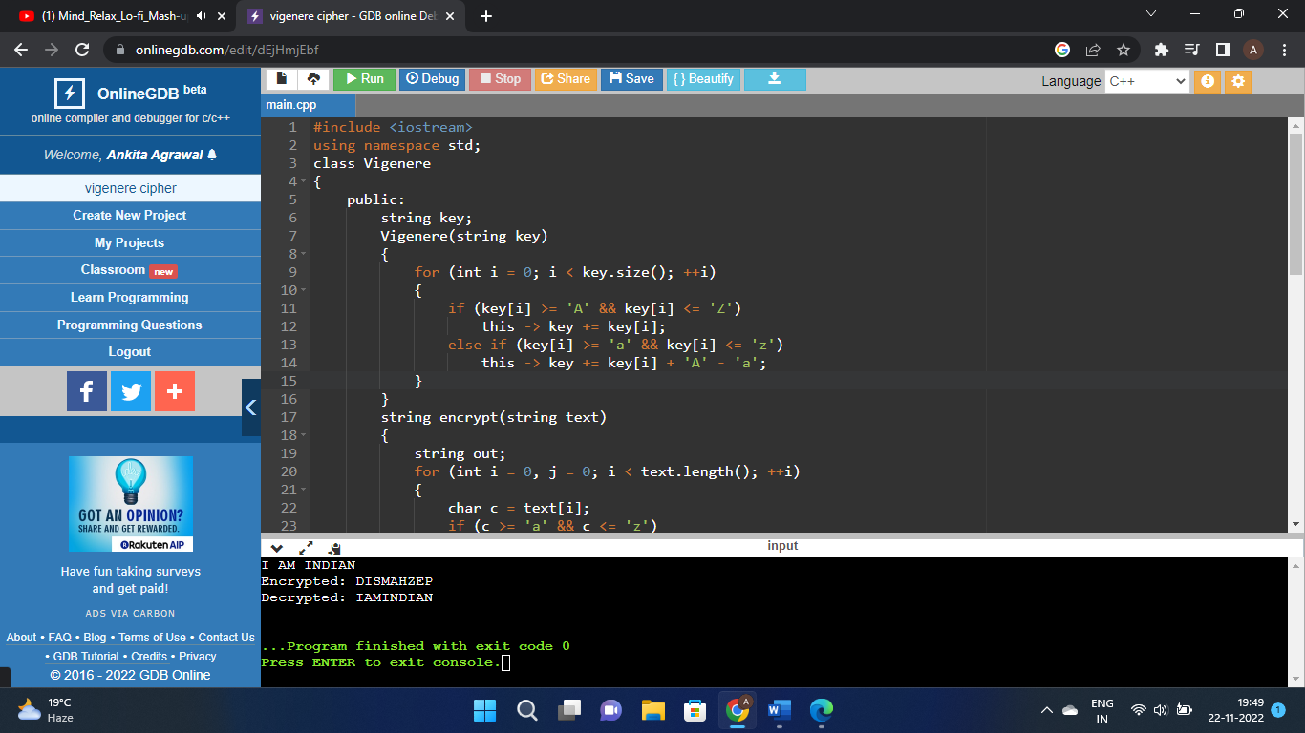

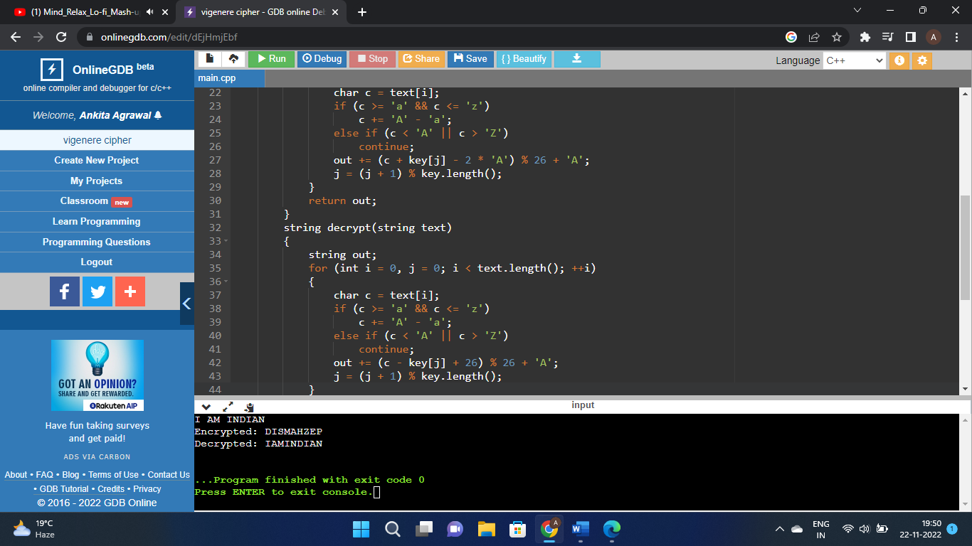

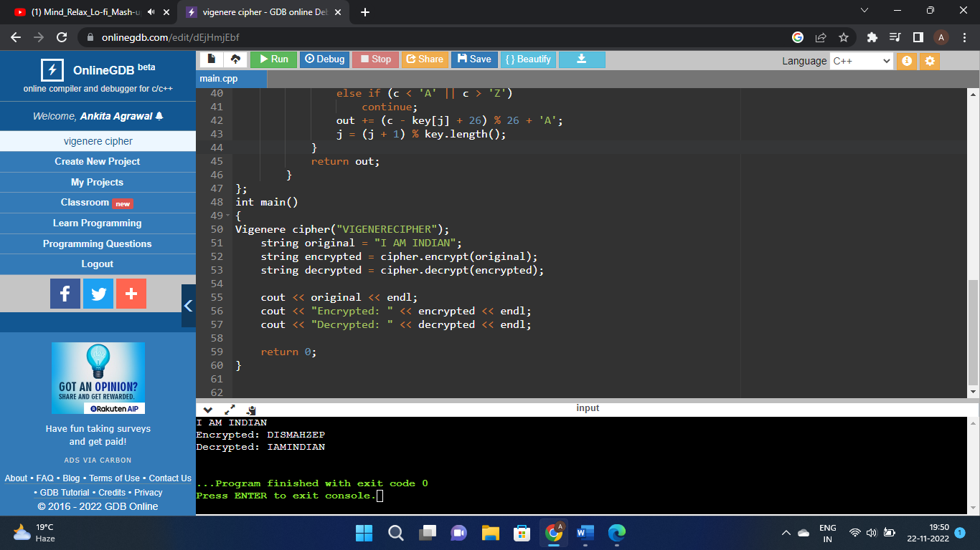

1. Write a program to implement Autokey Cipher.

* Plaintext should be in lowercase.
* Ciphertext should be uppercase.
* Brute force attack.

Code:

import java.lang.*;

import java.util.*;

public class Main {

private static final String alphabet = "ABCDEFGHIJKLMNOPQRSTUVWXYZ";

public static void main(String[] args)

{

String msg = "HELLO";

String key = "N";

if (key.matches("[-+]?\\d*\\.?\\d+"))

key = "" + alphabet.charAt(Integer.parseInt(key));

String enc = autoEncryption(msg, key);

System.out.println("Plaintext : " + msg);

System.out.println("Encrypted : " + enc);

System.out.println("Decrypted : " + autoDecryption(enc, key));

}

public static String autoEncryption(String msg, String key)

{

int len = msg.length();

String newKey = key.concat(msg);

newKey = newKey.substring(0, newKey.length() - key.length());

String encryptMsg = "";

for (int x = 0; x < len; x++) {

int first = alphabet.indexOf(msg.charAt(x));

int second = alphabet.indexOf(newKey.charAt(x));

int total = (first + second) % 26;

encryptMsg += alphabet.charAt(total);

}

return encryptMsg;

}

public static String autoDecryption(String msg, String key)

{

String currentKey = key;

String decryptMsg = "";

for (int x = 0; x < msg.length(); x++) {

int get1 = alphabet.indexOf(msg.charAt(x));

int get2 = alphabet.indexOf(currentKey.charAt(x));

int total = (get1 - get2) % 26;

total = (total < 0) ? total + 26 : total;

decryptMsg += alphabet.charAt(total);

currentKey += alphabet.charAt(total);

}

return decryptMsg;

}

}

ScreenShot:

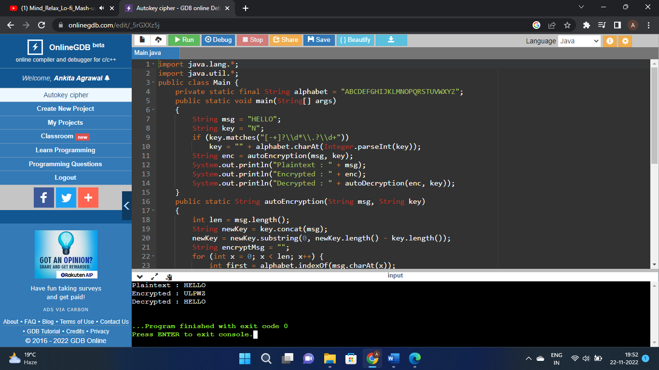

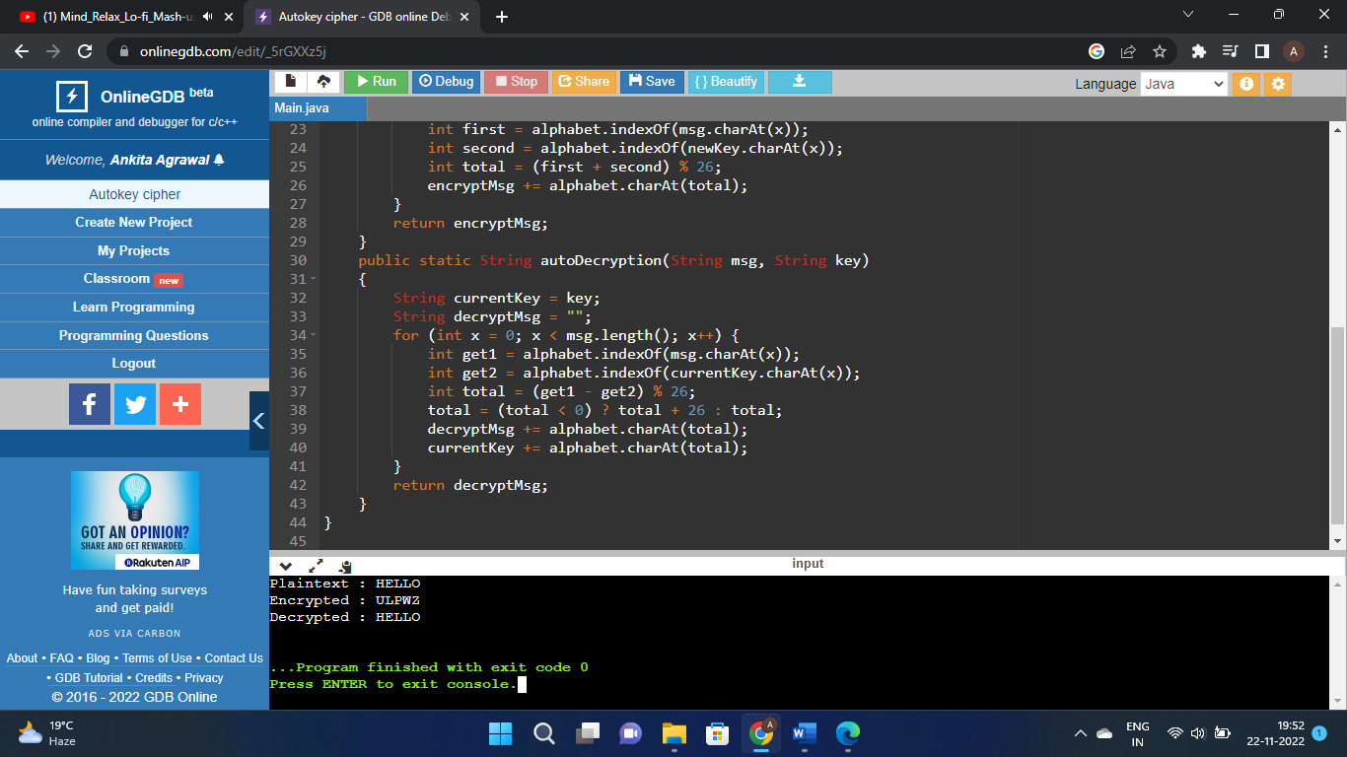

1. Write a program to implement Playfair Cipher to encrypt & decrypt the given message where the key matrix can be formed by using a given keyword.

Code:

import java.util.*;

public class Main

{

static int SIZE = 30;

static void toLowerCase(char plain[], int ps)

{

int i;

for (i = 0; i < ps; i++) {

if (plain[i] > 64 && plain[i] < 91)

plain[i] += 32;

}

}

static int removeSpaces(char[] plain, int ps)

{

int i, count = 0;

for (i = 0; i < ps; i++)

if (plain[i] != '\u0000')

plain[count++] = plain[i];

return count;

}

static void generateKeyTable(char key[], int ks, char keyT[][])

{

int i, j, k, flag = 0;

int dicty[] = new int[26];

for (i = 0; i < ks; i++) {

if (key[i] != 'j')

dicty[key[i] - 97] = 2;

}

dicty['j' - 97] = 1;

i = 0;

j = 0;

for (k = 0; k < ks; k++) {

if (dicty[key[k] - 97] == 2) {

dicty[key[k] - 97] -= 1;

keyT[i][j] = key[k];

j++;

if (j == 5) {

i++;

j = 0;

}

}

}

for (k = 0; k < 26; k++) {

if (dicty[k] == 0) {

keyT[i][j] = (char)(k + 97);

j++;

if (j == 5) {

i++;

j = 0;

}

}

}

}

static void search(char keyT[][], char a, char b, int arr[])

{

int i, j;

if (a == 'j')

a = 'i';

else if (b == 'j')

b = 'i';

for (i = 0; i < 5; i++) {

for (j = 0; j < 5; j++) {

if (keyT[i][j] == a) {

arr[0] = i;

arr[1] = j;

}

else if (keyT[i][j] == b) {

arr[2] = i;

arr[3] = j;

}

}

}

}

static int mod5(int a) { return (a % 5); }

static int prepare(char str[], int ptrs)

{

if (ptrs % 2 != 0) {

str[ptrs++] = 'z';

str[ptrs] = '\0';

}

return ptrs;

}

static void encrypt(char str[], char keyT[][], int ps)

{

int i;

int[] a =new int[4];

for (i = 0; i < ps; i += 2) {

search(keyT, str[i], str[i + 1], a);

if (a[0] == a[2]) {

str[i] = keyT[a[0]][mod5(a[1] + 1)];

str[i + 1] = keyT[a[0]][mod5(a[3] + 1)];

}

else if (a[1] == a[3]) {

str[i] = keyT[mod5(a[0] + 1)][a[1]];

str[i + 1] = keyT[mod5(a[2] + 1)][a[1]];

}

else {

str[i] = keyT[a[0]][a[3]];

str[i + 1] = keyT[a[2]][a[1]];

}

}

}

static void encryptByPlayfairCipher(char str[], char key[])

{

int ps;

int ks;

char[][] keyT = new char[5][5];

// Key

ks = key.length;

ks = removeSpaces(key, ks);

toLowerCase(key, ks);

ps = str.length;

toLowerCase(str, ps);

ps = removeSpaces(str, ps);

ps = prepare(str, ps);

generateKeyTable(key, ks, keyT);

encrypt(str, keyT, ps);

}

static void strcpy(char[] arr, String s) {

for(int i = 0;i < s.length();i++){

arr[i] = s.charAt(i);

}

}

public static void main(String[] args) {

char str[] = new char[SIZE];

char key[] = new char[SIZE];

strcpy(key, "Monarchy");

System.out.println("Key text: " + String.valueOf(key));

strcpy(str, "instruments");

System.out.println("Plain text: " + String.valueOf(str));

encryptByPlayfairCipher(str, key);

System.out.println("Cipher text: " + String.valueOf(str));

}

}

ScreenShot:

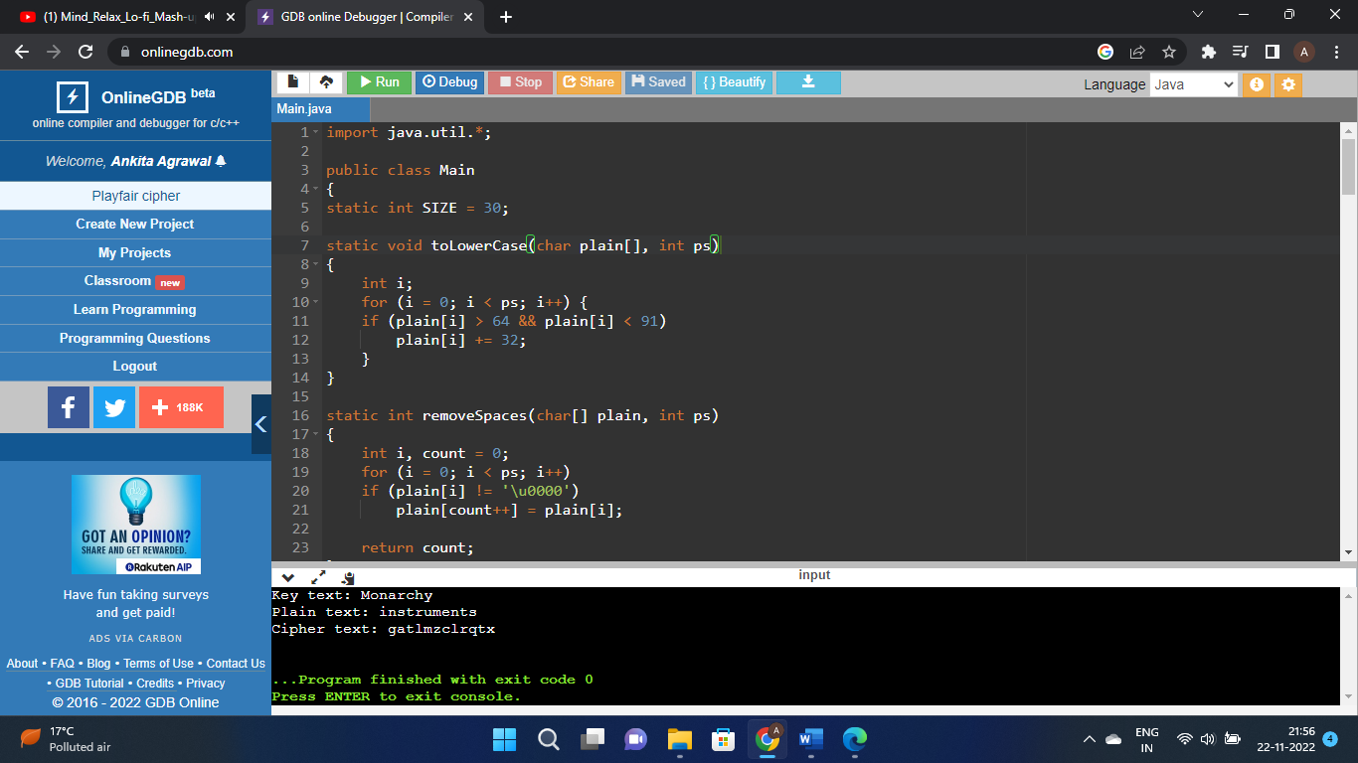

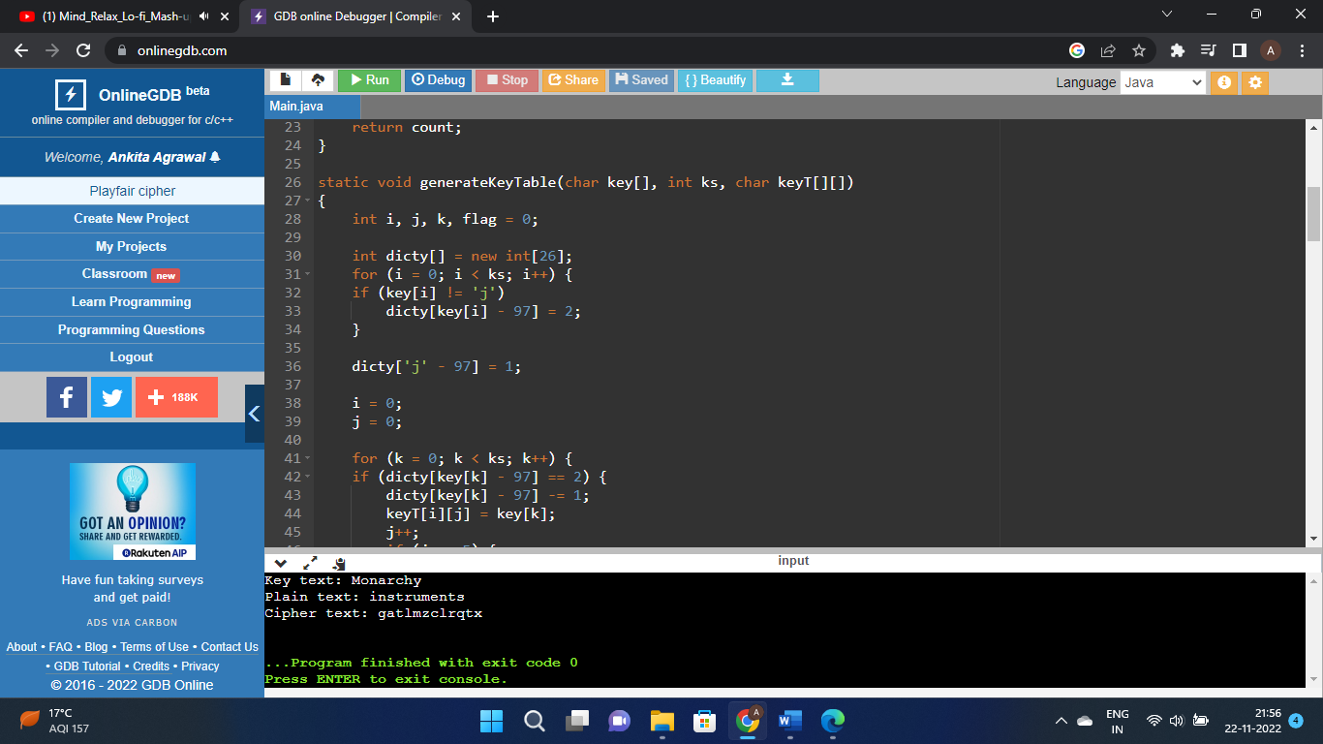

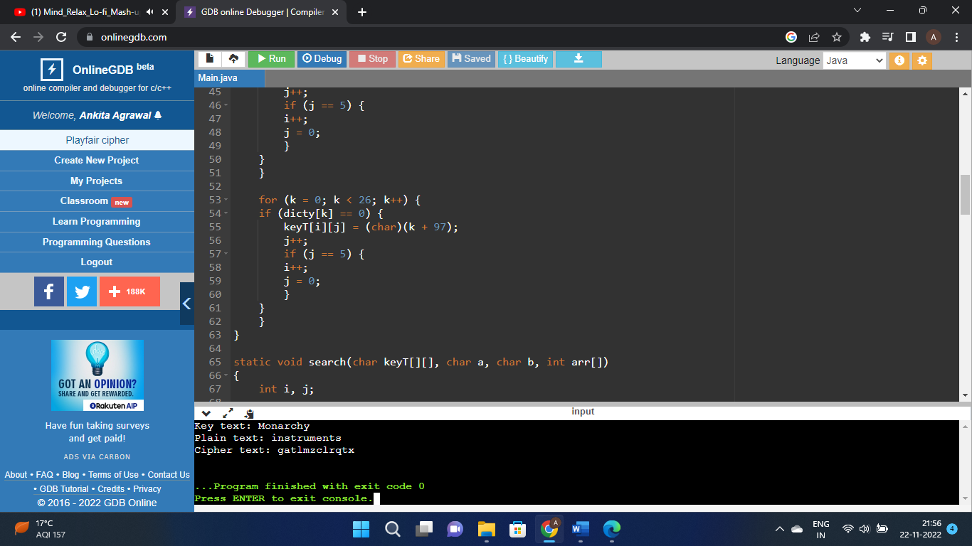

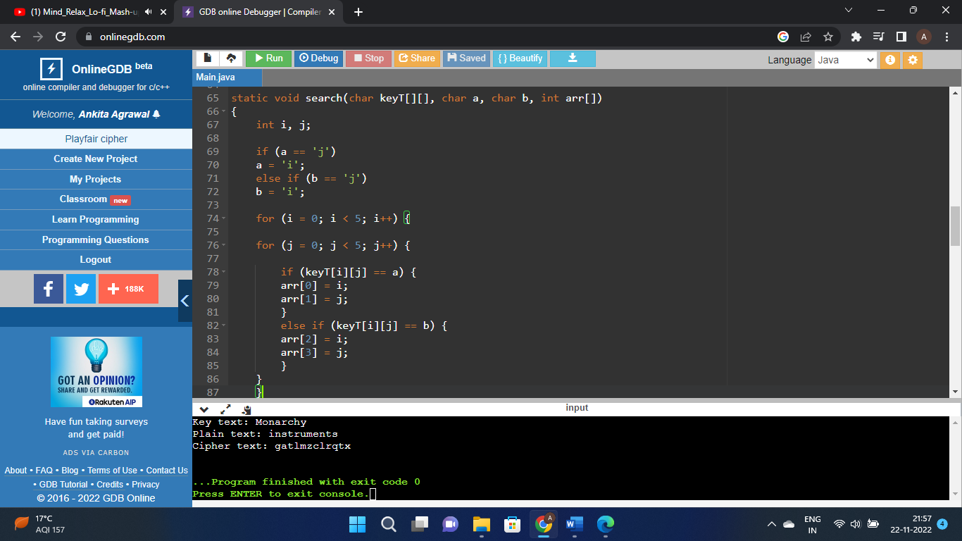

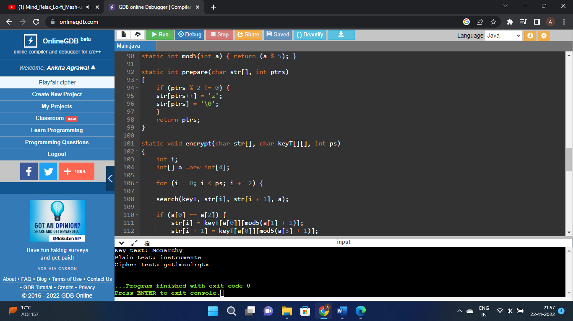

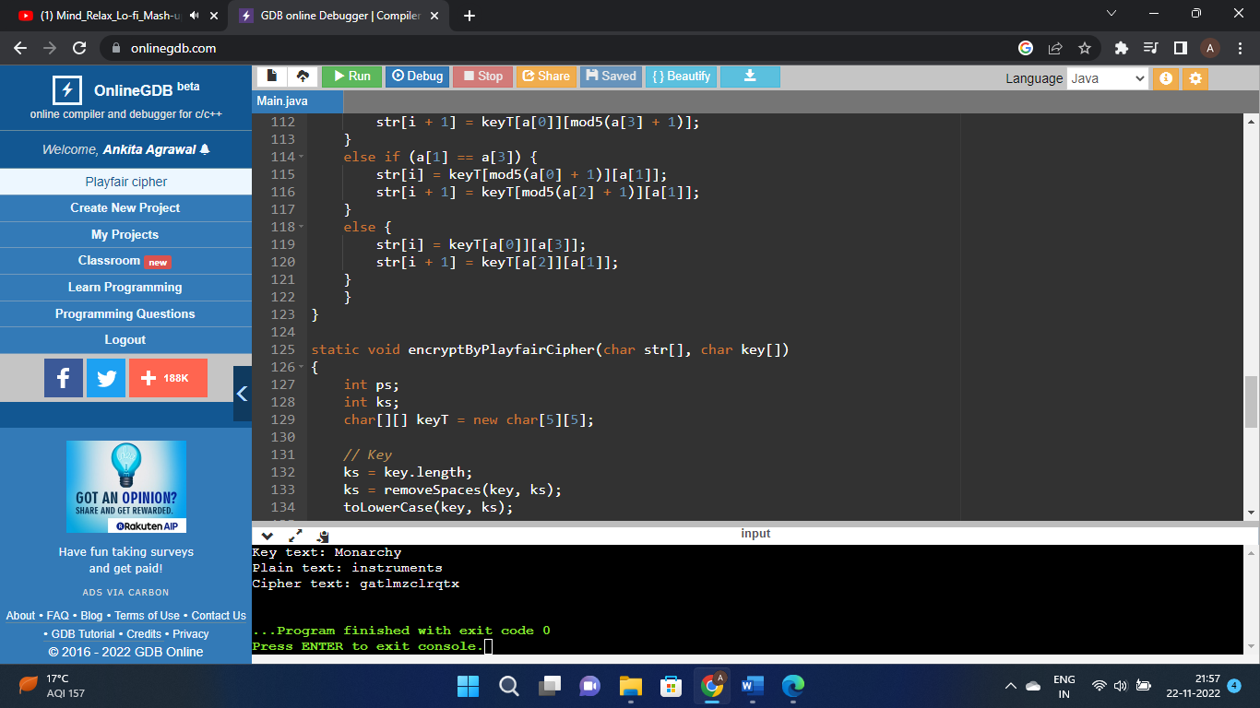

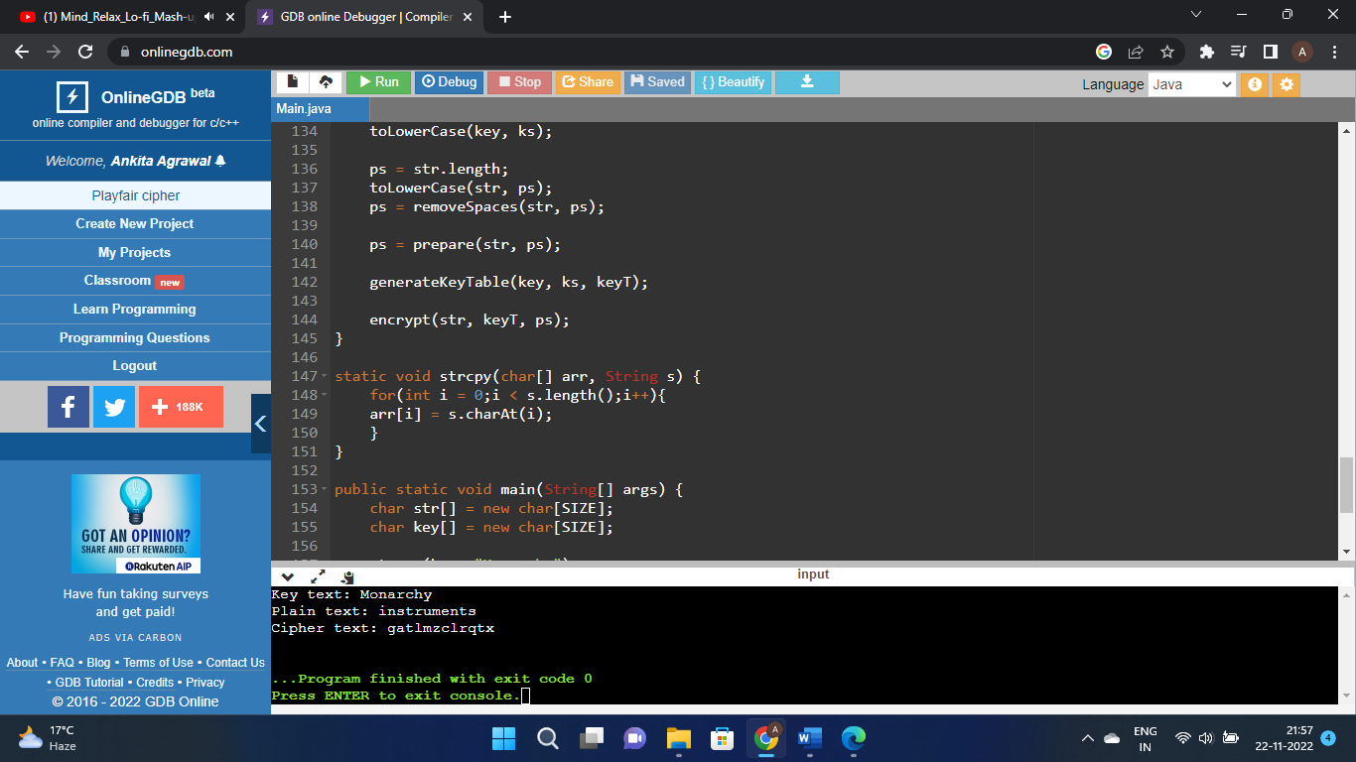

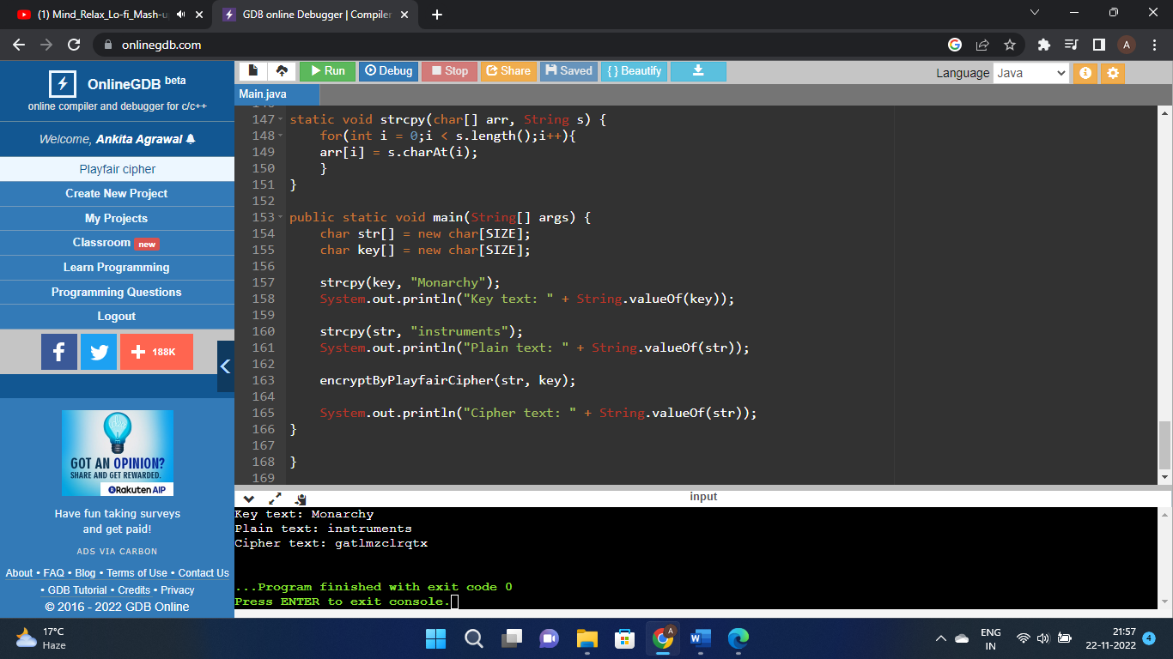

1. Write a program to implement Hill Cipher to encrypt & decrypt the given message by using a given key matrix. Show the values for key and its corresponding key inverse values.

Code:

class Main

{

static void getKeyMatrix(String key, int keyMatrix[][])

{

int k = 0;

for (int i = 0; i < 3; i++)

{

for (int j = 0; j < 3; j++)

{

keyMatrix[i][j] = (key.charAt(k)) % 65;

k++;

}

}

}

static void encrypt(int cipherMatrix[][],

int keyMatrix[][],

int messageVector[][])

{

int x, i, j;

for (i = 0; i < 3; i++)

{

for (j = 0; j < 1; j++)

{

cipherMatrix[i][j] = 0;

for (x = 0; x < 3; x++)

{

cipherMatrix[i][j] +=

keyMatrix[i][x] * messageVector[x][j];

}

cipherMatrix[i][j] = cipherMatrix[i][j] % 26;

}

}

}

static void HillCipher(String message, String key)

{

int [][]keyMatrix = new int[3][3];

getKeyMatrix(key, keyMatrix);

int [][]messageVector = new int[3][1];

for (int i = 0; i < 3; i++)

messageVector[i][0] = (message.charAt(i)) % 65;

int [][]cipherMatrix = new int[3][1];

encrypt(cipherMatrix, keyMatrix, messageVector);

String CipherText="";

for (int i = 0; i < 3; i++)

CipherText += (char)(cipherMatrix[i][0] + 65);

System.out.print(" Ciphertext:" + CipherText);

}

public static void main(String[] args)

{

String message = "ACT";

// Get the key

String key = "GYBNQKURP";

HillCipher(message, key);

}

}

Screenshot:

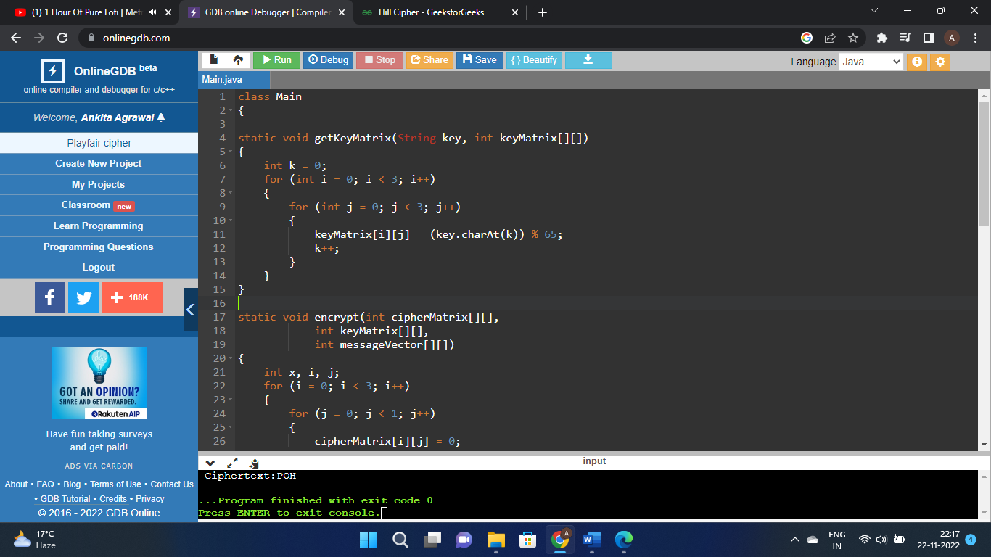

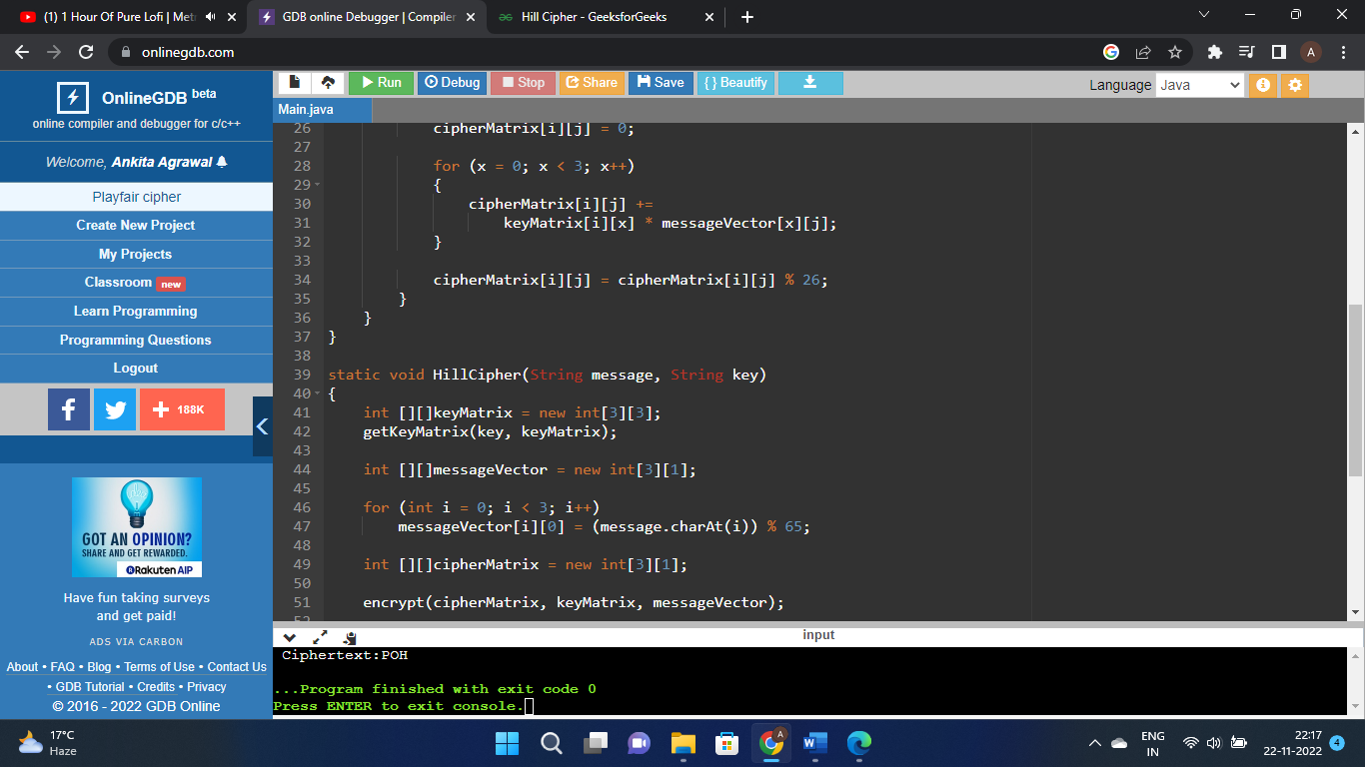

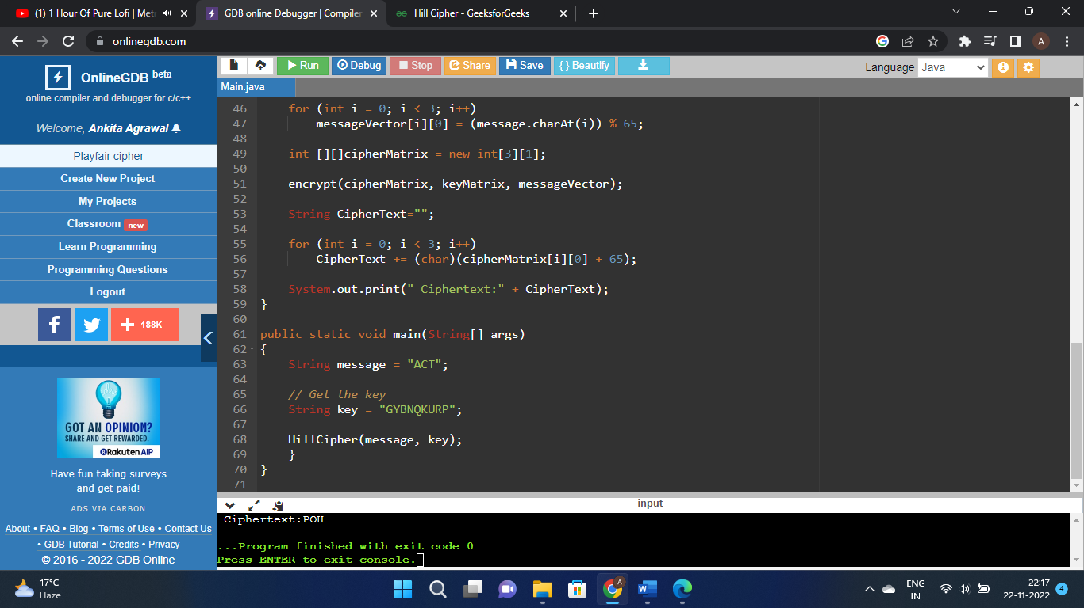

1. Write a program to implement Rail Fence Cipher to encrypt & decrypt the given message by using the following conditions:
   * Plaintext should be in lowercase.
   * Ciphertext should be uppercase.

Code:

def encryptRailFence(text, key):

rail = [['\n' for i in range(len(text))]

for j in range(key)]

dir_down = False

row, col = 0, 0

for i in range(len(text)):

if (row == 0) or (row == key - 1):

dir_down = not dir_down

rail[row][col] = text[i]

col += 1

if dir_down:

row += 1

else:

row -= 1

result = []

for i in range(key):

for j in range(len(text)):

if rail[i][j] != '\n':

result.append(rail[i][j])

return("" . join(result))

def decryptRailFence(cipher, key):

rail = [['\n' for i in range(len(cipher))]

for j in range(key)]

dir_down = None

row, col = 0, 0

for i in range(len(cipher)):

if row == 0:

dir_down = True

if row == key - 1:

dir_down = False

rail[row][col] = '*'

col += 1

if dir_down:

row += 1

else:

row -= 1

index = 0

for i in range(key):

for j in range(len(cipher)):

if ((rail[i][j] == '*') and

(index < len(cipher))):

rail[i][j] = cipher[index]

index += 1

result = []

row, col = 0, 0

for i in range(len(cipher)):

if row == 0:

dir_down = True

if row == key-1:

dir_down = False

if (rail[row][col] != '*'):

result.append(rail[row][col])

col += 1

if dir_down:

row += 1

else:

row -= 1

return("".join(result))

if __name__ == "__main__":

print(encryptRailFence("attack at once", 2))

print(encryptRailFence("GeeksforGeeks ", 3))

print(encryptRailFence("defend the east wall", 3))

print(decryptRailFence("GsGsekfrek eoe", 3))

print(decryptRailFence("atc toctaka ne", 2))

print(decryptRailFence("dnhaweedtees alf tl", 3))

ScreenShot:

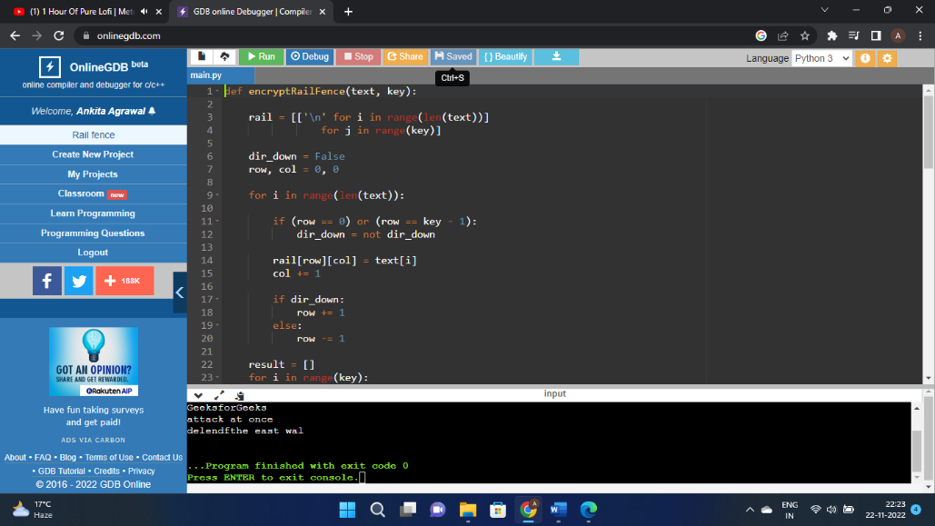

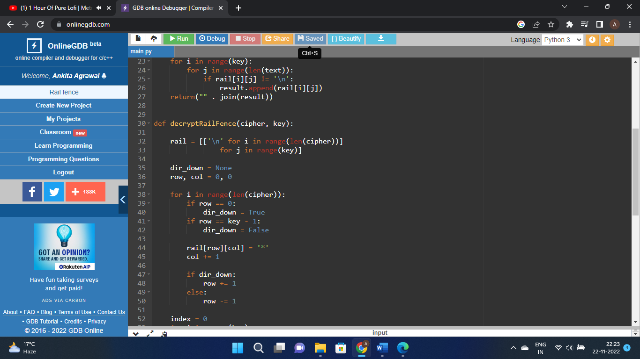

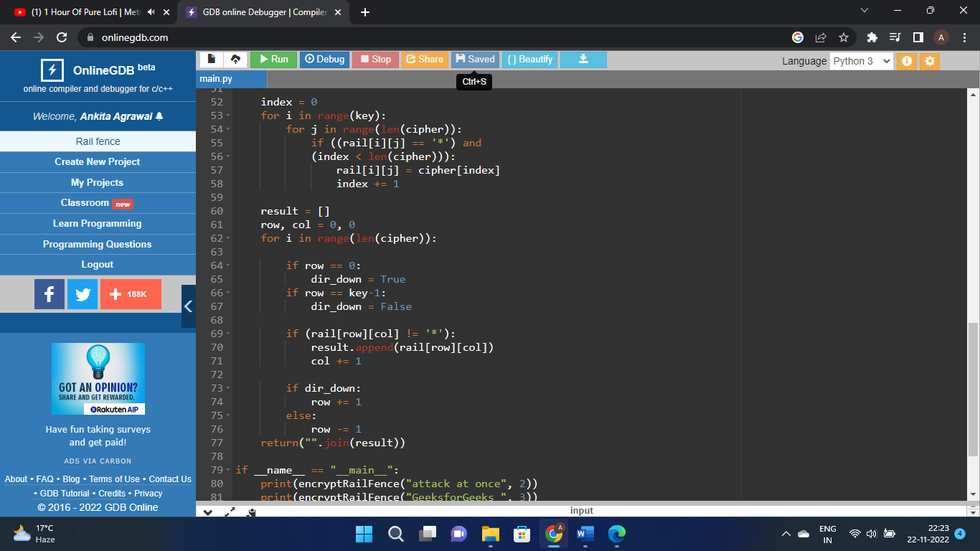

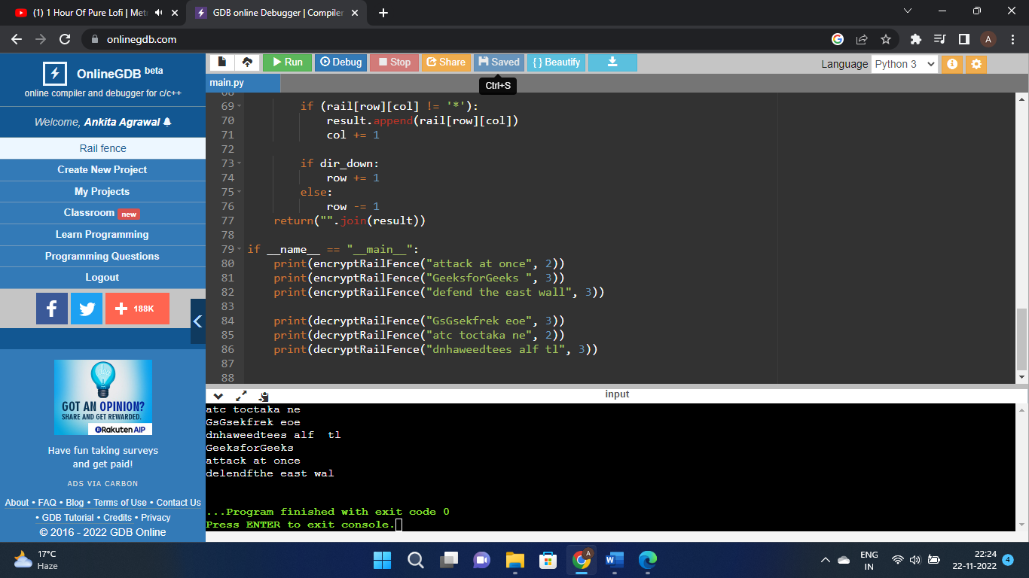

1. W.A.P. to implement Columner Transposition technique to show the encryption & decryption process for any given message.

Code:

import math

key = "HACK"

def encryptMessage(msg):

cipher = ""

k_indx = 0

msg_len = float(len(msg))

msg_lst = list(msg)

key_lst = sorted(list(key))

col = len(key)

row = int(math.ceil(msg_len / col))

fill_null = int((row * col) - msg_len)

msg_lst.extend('_' * fill_null)

matrix = [msg_lst[i: i + col]

for i in range(0, len(msg_lst), col)]

for _ in range(col):

curr_idx = key.index(key_lst[k_indx])

cipher += ''.join([row[curr_idx]

for row in matrix])

k_indx += 1

return cipher

def decryptMessage(cipher):

msg = ""

k_indx = 0

msg_indx = 0

msg_len = float(len(cipher))

msg_lst = list(cipher)

col = len(key)

row = int(math.ceil(msg_len / col))

key_lst = sorted(list(key))

dec_cipher = []

for _ in range(row):

dec_cipher += [[None] * col]

for _ in range(col):

curr_idx = key.index(key_lst[k_indx])

for j in range(row):

dec_cipher[j][curr_idx] = msg_lst[msg_indx]

msg_indx += 1

k_indx += 1

try:

msg = ''.join(sum(dec_cipher, []))

except TypeError:

raise TypeError("This program cannot",

"handle repeating words.")

null_count = msg.count('_')

if null_count > 0:

return msg[: -null_count]

return msg

msg = "Geeks for Geeks"

cipher = encryptMessage(msg)

print("Encrypted Message: {}".

format(cipher))

print("Decryped Message: {}".

format(decryptMessage(cipher)))

ScreenShot:

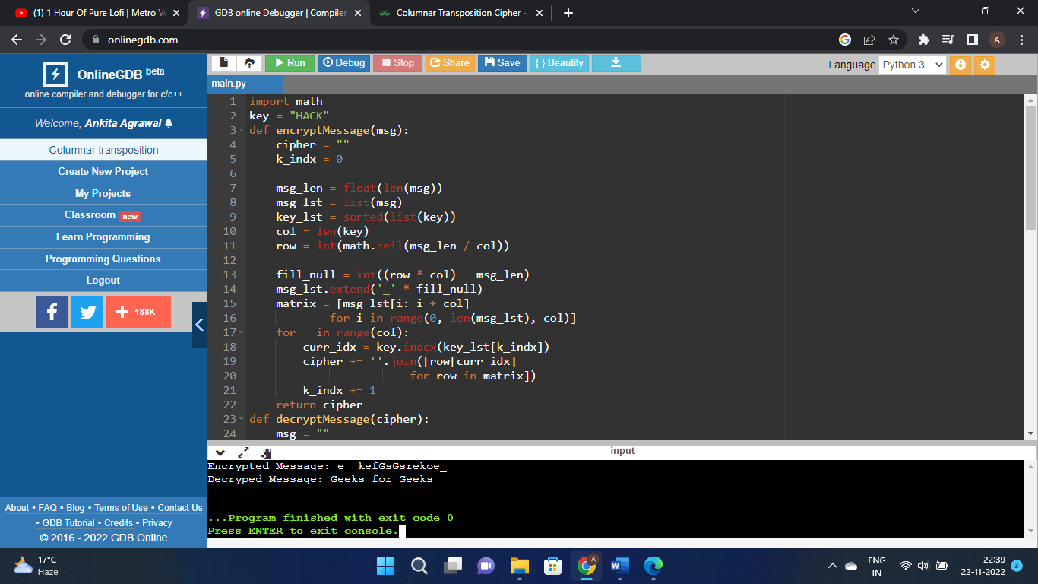

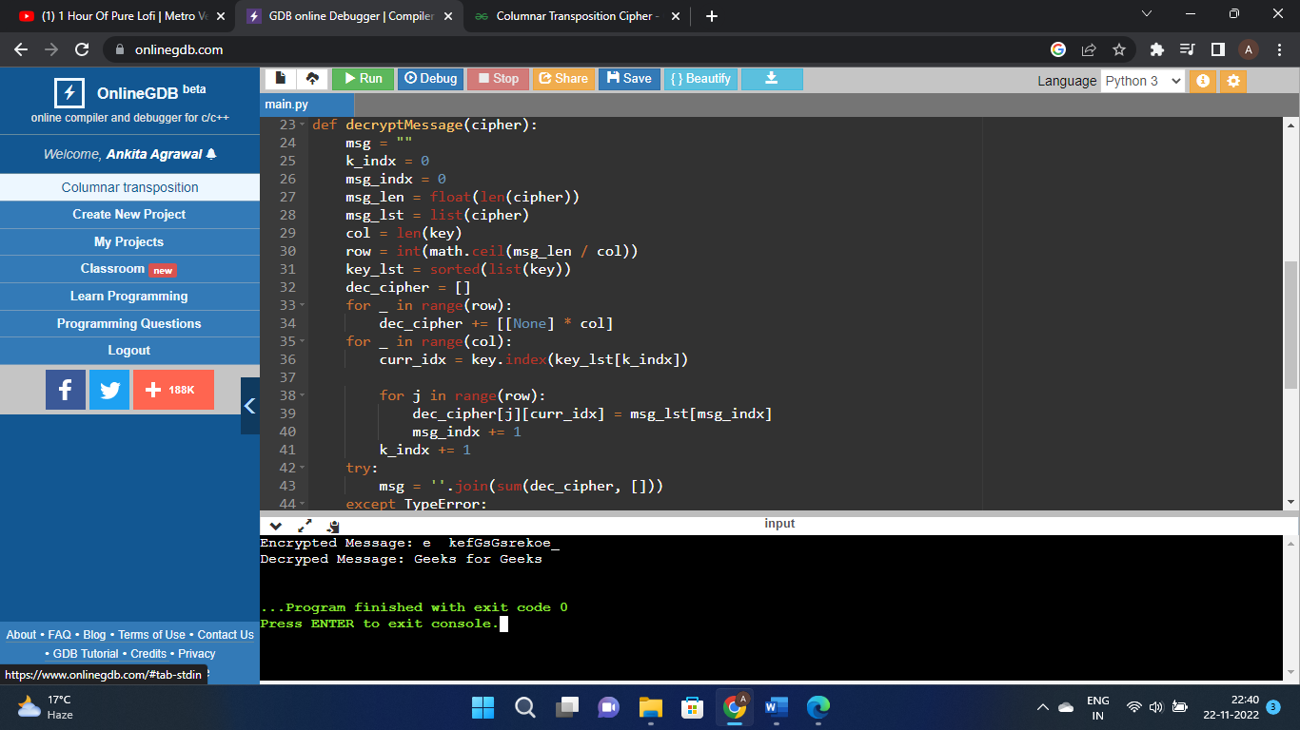

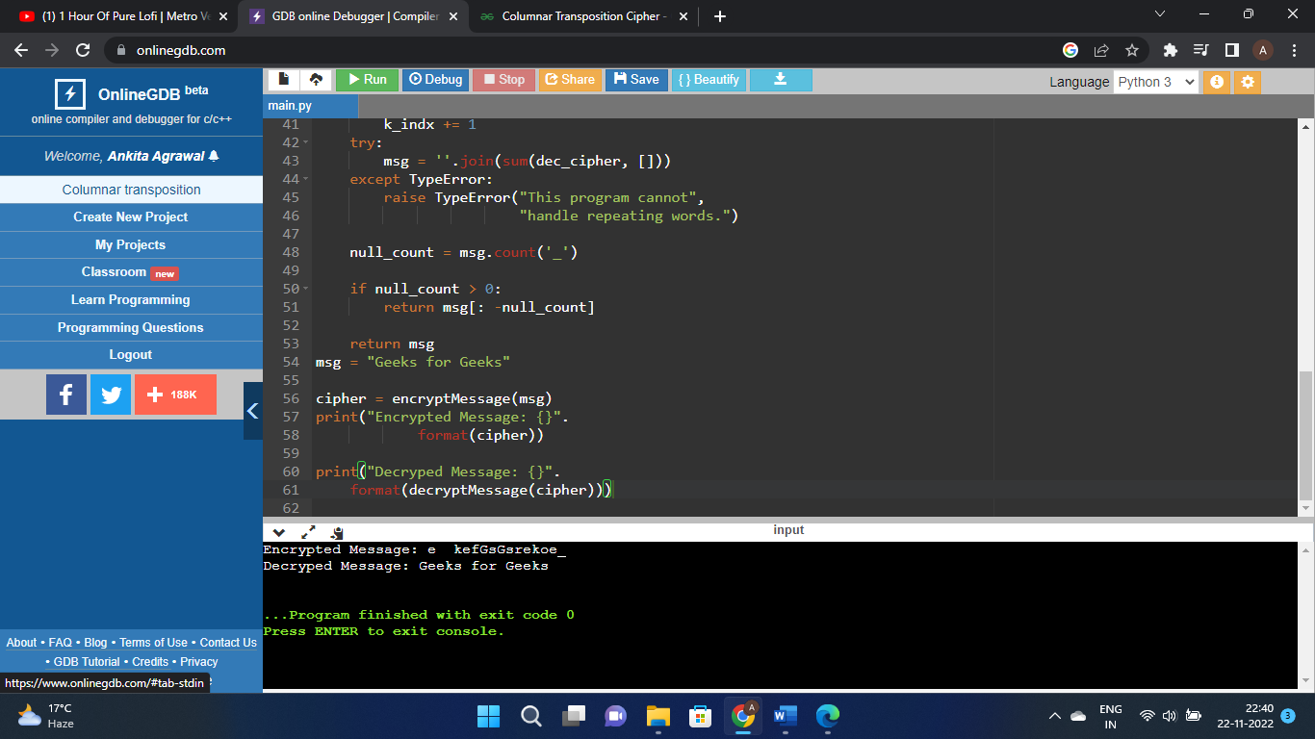

1. W.A.P. to implement Euclidean Algorithm to find the GCD of given numbers.

Code:

def gcdExtended(a, b):

# Base Case

if a == 0:

return b, 0, 1

gcd, x1, y1 = gcdExtended(b % a, a)

x = y1 - (b//a) * x1

y = x1

return gcd, x, y

a, b = 35, 15

g, x, y = gcdExtended(a, b)

print("gcd(", a, ",", b, ") = ", g)

ScreenShot:

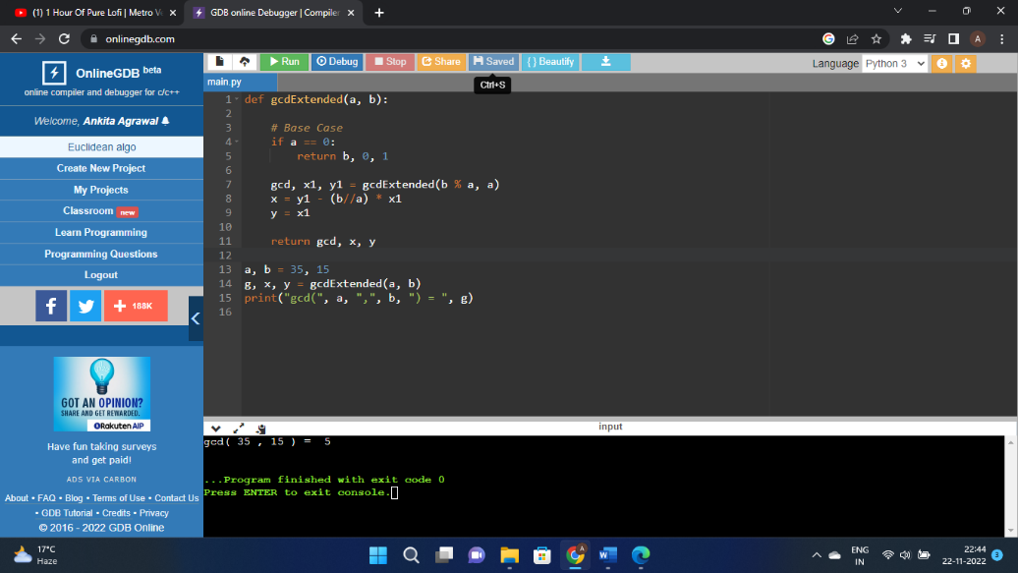

1. Write a program to find out the Multiplicative inverse of a given number without using extended Euclidean algorithm.

Code:

def modInverse(A, M):

for X in range(1, M):

if (((A % M) * (X % M)) % M == 1):

return X

return -1

if __name__ == "__main__":

A = 3

M = 11

print(modInverse(A, M))

ScreenShot:

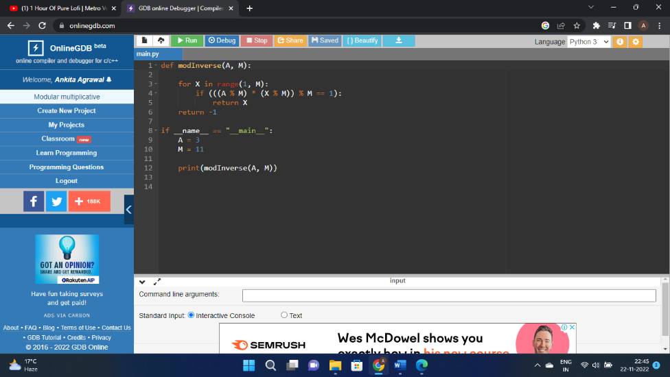

1. Write a program to find out the Multiplicative inverse of a given number by using Extended Euclidean algorithm.

Code:

def modInverse(A, M):

for X in range(1, M):

if (((A % M) * (X % M)) % M == 1):

return X

return -1

if __name__ == "__main__":

A = 3

M = 11

print(modInverse(A, M))

ScreenShot:

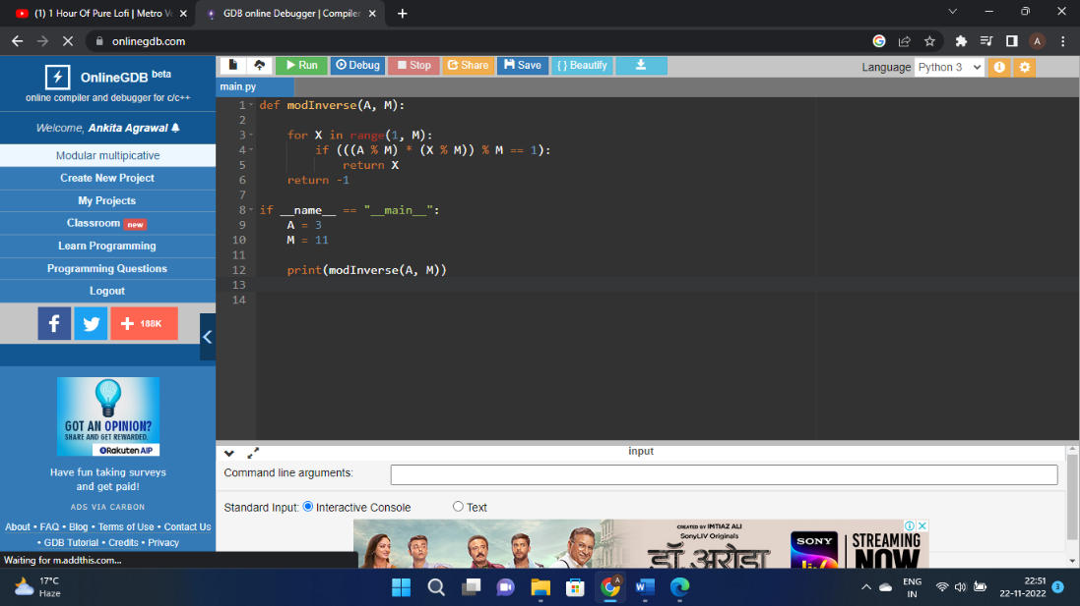

1. Write a program to implement Elgamal Cryptosystem to generate the pair of keys and then show the encryption & decryption of a given message.

Code:

import random

from math import pow

a = random.randint(2, 10)

def gcd(a, b):

if a < b:

return gcd(b, a)

elif a % b == 0:

return b;

else:

return gcd(b, a % b)

def gen_key(q):

key = random.randint(pow(10, 20), q)

while gcd(q, key) != 1:

key = random.randint(pow(10, 20), q)

return key

def power(a, b, c):

x = 1

y = a

while b > 0:

if b % 2 != 0:

x = (x * y) % c;

y = (y * y) % c

b = int(b / 2)

return x % c

def encrypt(msg, q, h, g):

en_msg = []

k = gen_key(q)

s = power(h, k, q)

p = power(g, k, q)

for i in range(0, len(msg)):

en_msg.append(msg[i])

print("g^k used : ", p)

print("g^ak used : ", s)

for i in range(0, len(en_msg)):

en_msg[i] = s * ord(en_msg[i])

return en_msg, p

def decrypt(en_msg, p, key, q):

dr_msg = []

h = power(p, key, q)

for i in range(0, len(en_msg)):

dr_msg.append(chr(int(en_msg[i]/h)))

return dr_msg

def main():

msg = 'encryption'

print("Original Message :", msg)

q = random.randint(pow(10, 20), pow(10, 50))

g = random.randint(2, q)

key = gen_key(q)

h = power(g, key, q)

print("g used : ", g)

print("g^a used : ", h)

en_msg, p = encrypt(msg, q, h, g)

dr_msg = decrypt(en_msg, p, key, q)

dmsg = ''.join(dr_msg)

print("Decrypted Message :", dmsg);

if __name__ == '__main__':

main()

ScreenShot:

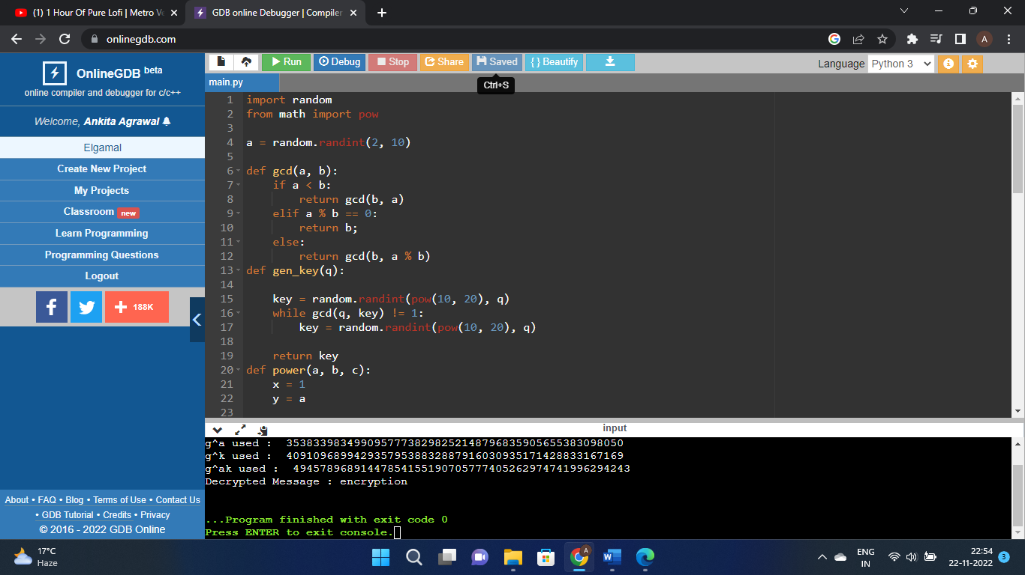

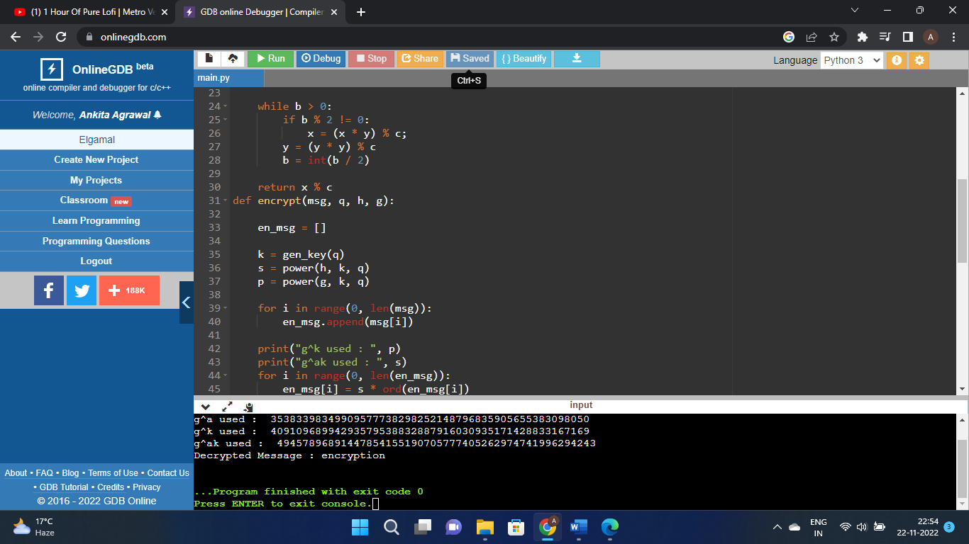

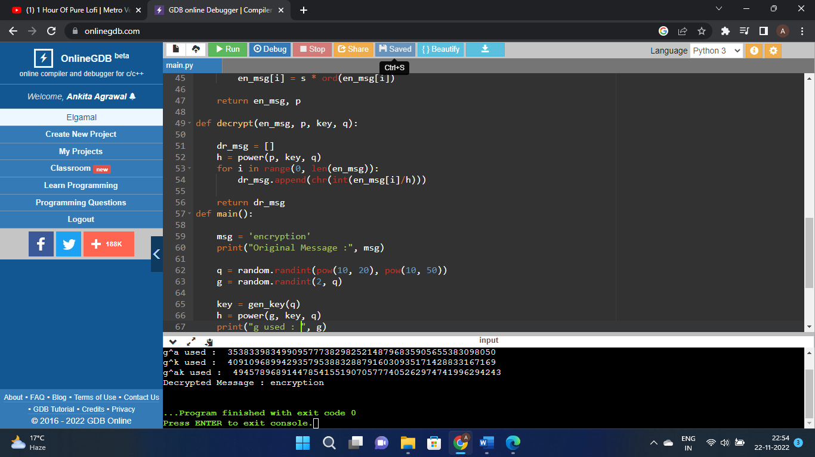

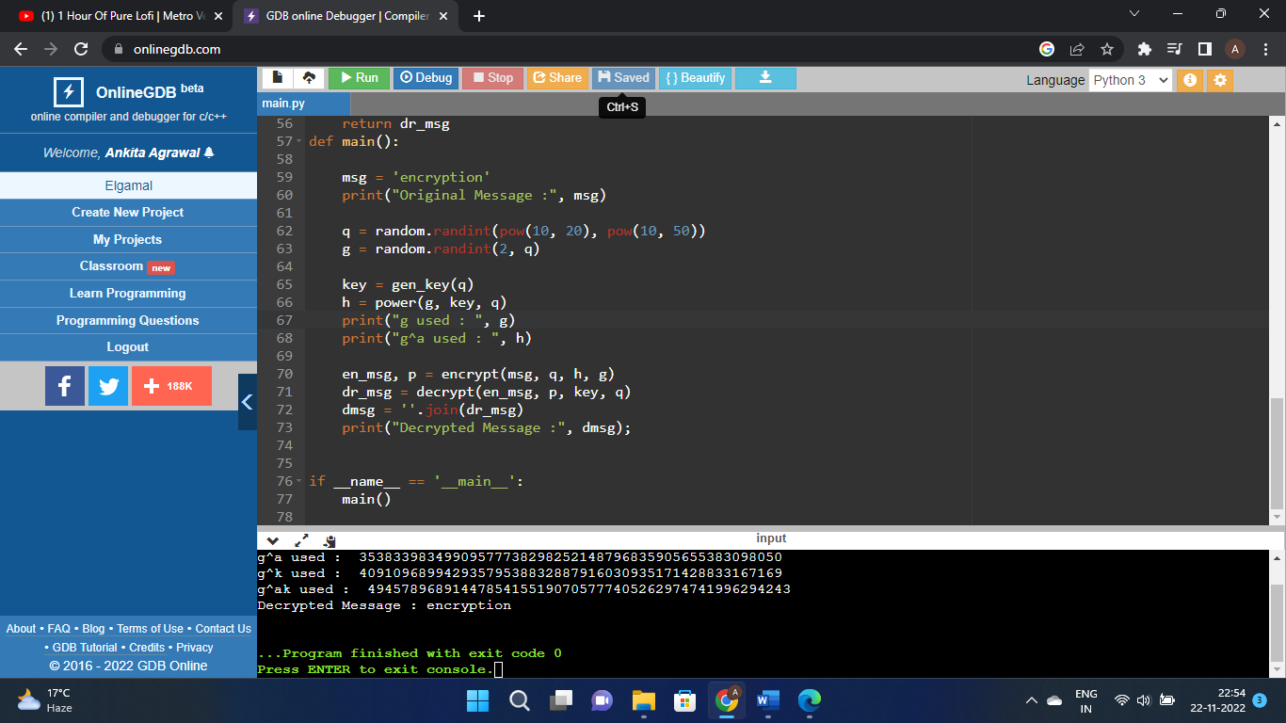

1. Write a program to implement Rabin Miller Primality Test to check whether given number is prime or composite.

Code:

import random

def power(x, y, p):

res = 1;

x = x % p;

while (y > 0):

if (y & 1):

res = (res * x) % p;

y = y>>1;

x = (x * x) % p;

return res;

def miillerTest(d, n):

a = 2 + random.randint(1, n - 4);

x = power(a, d, n);

if (x == 1 or x == n - 1):

return True;

while (d != n - 1):

x = (x * x) % n;

d *= 2;

if (x == 1):

return False;

if (x == n - 1):

return True;

return False;

def isPrime( n, k):

if (n <= 1 or n == 4):

return False;

if (n <= 3):

return True;

d = n - 1;

while (d % 2 == 0):

d //= 2;

for i in range(k):

if (miillerTest(d, n) == False):

return False;

return True;

k = 4;

print("All primes smaller than 100: ");

for n in range(1,100):

if (isPrime(n, k)):

print(n , end=" ");

ScreenShot:

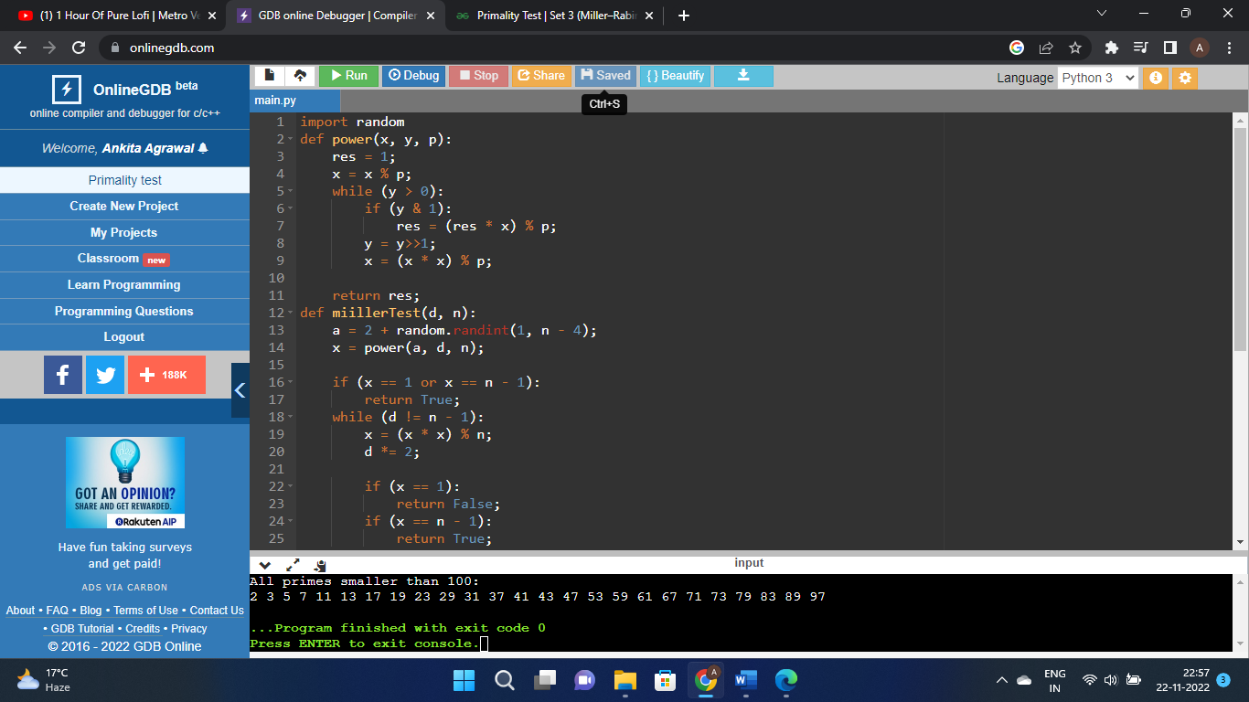

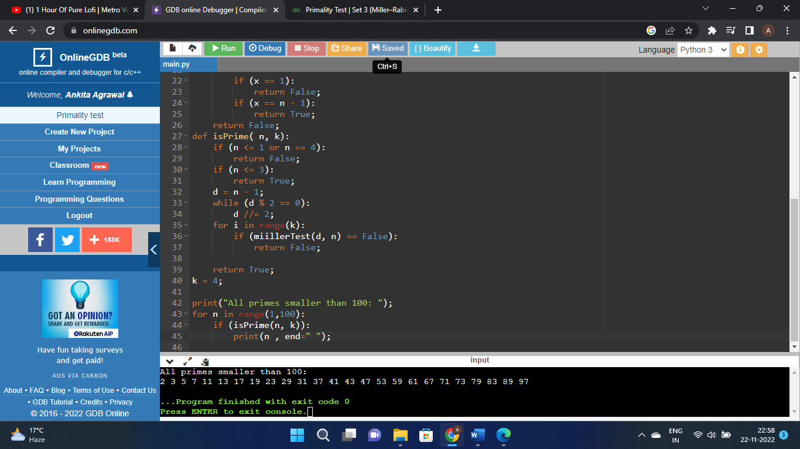

1. Write a program to implement Diffie-Hellman key exchange Algorithm to exchange the symmetric key and show the encryption & decryption.

Code:

from random import randint

if __name__ == '__main__':

P = 23

G = 9

print('The Value of P is :%d'%(P))

print('The Value of G is :%d'%(G))

a = 4

print('The Private Key a for Alice is :%d'%(a))

x = int(pow(G,a,P))

b = 3

print('The Private Key b for Bob is :%d'%(b))

y = int(pow(G,b,P))

ka = int(pow(y,a,P))

kb = int(pow(x,b,P))

print('Secret key for the Alice is : %d'%(ka))

print('Secret Key for the Bob is : %d'%(kb))

ScreenShot: 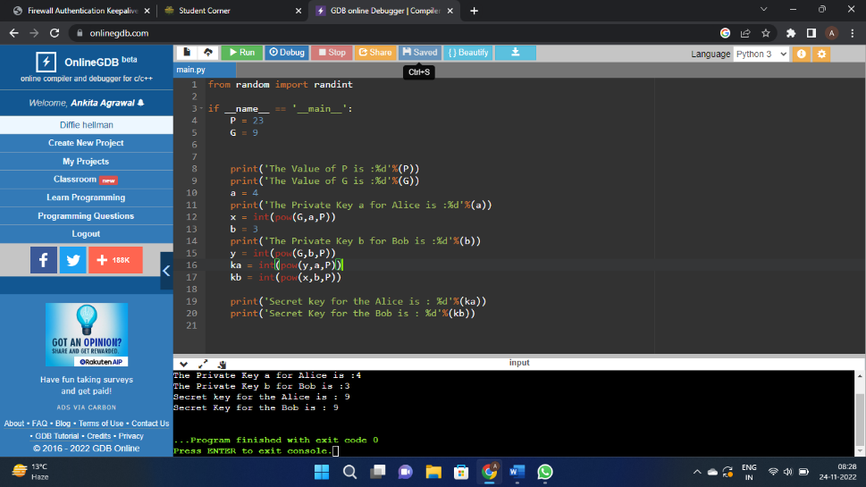

1. Write a program to implement Digital Signature Standard (DSS) Algorithm to generate different signature components and verify them.

Code:

import java.io.*;

import java.security.*;

public class Main

{

public static void main(String args[])

{

if (args.length != 1)

{

System.out.println("Usage: nameOfFileToSign");

}

else try

{

}

catch (Exception e)

{

System.err.println("Caught exception " + e.toString());

}

}

}

ScreenShot: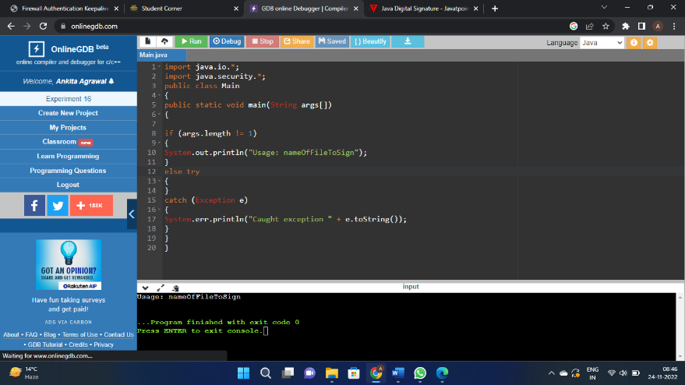

1. Write a program to implement S-DES to perform encryption and decryption of a given message.

Code:

def hex2bin(s):

mp = {'0': "0000",

'1': "0001",

'2': "0010",

'3': "0011",

'4': "0100",

'5': "0101",

'6': "0110",

'7': "0111",

'8': "1000",

'9': "1001",

'A': "1010",

'B': "1011",

'C': "1100",

'D': "1101",

'E': "1110",

'F': "1111"}

bin = ""

for i in range(len(s)):

bin = bin + mp[s[i]]

return bin

def bin2hex(s):

mp = {"0000": '0',

"0001": '1',

"0010": '2',

"0011": '3',

"0100": '4',

"0101": '5',

"0110": '6',

"0111": '7',

"1000": '8',

"1001": '9',

"1010": 'A',

"1011": 'B',

"1100": 'C',

"1101": 'D',

"1110": 'E',

"1111": 'F'}

hex = ""

for i in range(0, len(s), 4):

ch = ""

ch = ch + s[i]

ch = ch + s[i + 1]

ch = ch + s[i + 2]

ch = ch + s[i + 3]

hex = hex + mp[ch]

return hex

def bin2dec(binary):

binary1 = binary

decimal, i, n = 0, 0, 0

while(binary != 0):

dec = binary % 10

decimal = decimal + dec * pow(2, i)

binary = binary//10

i += 1

return decimal

def dec2bin(num):

res = bin(num).replace("0b", "")

if(len(res) % 4 != 0):

div = len(res) / 4

div = int(div)

counter = (4 * (div + 1)) - len(res)

for i in range(0, counter):

res = '0' + res

return res

def permute(k, arr, n):

permutation = ""

for i in range(0, n):

permutation = permutation + k[arr[i] - 1]

return permutation

def shift_left(k, nth_shifts):

s = ""

for i in range(nth_shifts):

for j in range(1, len(k)):

s = s + k[j]

s = s + k[0]

k = s

s = ""

return k

def xor(a, b):

ans = ""

for i in range(len(a)):

if a[i] == b[i]:

ans = ans + "0"

else:

ans = ans + "1"

return ans

initial_perm = [58, 50, 42, 34, 26, 18, 10, 2,

60, 52, 44, 36, 28, 20, 12, 4,

62, 54, 46, 38, 30, 22, 14, 6,

64, 56, 48, 40, 32, 24, 16, 8,

57, 49, 41, 33, 25, 17, 9, 1,

59, 51, 43, 35, 27, 19, 11, 3,

61, 53, 45, 37, 29, 21, 13, 5,

63, 55, 47, 39, 31, 23, 15, 7]

exp_d = [32, 1, 2, 3, 4, 5, 4, 5,

6, 7, 8, 9, 8, 9, 10, 11,

12, 13, 12, 13, 14, 15, 16, 17,

16, 17, 18, 19, 20, 21, 20, 21,

22, 23, 24, 25, 24, 25, 26, 27,

28, 29, 28, 29, 30, 31, 32, 1]

per = [16, 7, 20, 21,

29, 12, 28, 17,

1, 15, 23, 26,

5, 18, 31, 10,

2, 8, 24, 14,

32, 27, 3, 9,

19, 13, 30, 6,

22, 11, 4, 25]

sbox = [[[14, 4, 13, 1, 2, 15, 11, 8, 3, 10, 6, 12, 5, 9, 0, 7],

[0, 15, 7, 4, 14, 2, 13, 1, 10, 6, 12, 11, 9, 5, 3, 8],

[4, 1, 14, 8, 13, 6, 2, 11, 15, 12, 9, 7, 3, 10, 5, 0],

[15, 12, 8, 2, 4, 9, 1, 7, 5, 11, 3, 14, 10, 0, 6, 13]],

[[15, 1, 8, 14, 6, 11, 3, 4, 9, 7, 2, 13, 12, 0, 5, 10],

[3, 13, 4, 7, 15, 2, 8, 14, 12, 0, 1, 10, 6, 9, 11, 5],

[0, 14, 7, 11, 10, 4, 13, 1, 5, 8, 12, 6, 9, 3, 2, 15],

[13, 8, 10, 1, 3, 15, 4, 2, 11, 6, 7, 12, 0, 5, 14, 9]],

[[10, 0, 9, 14, 6, 3, 15, 5, 1, 13, 12, 7, 11, 4, 2, 8],

[13, 7, 0, 9, 3, 4, 6, 10, 2, 8, 5, 14, 12, 11, 15, 1],

[13, 6, 4, 9, 8, 15, 3, 0, 11, 1, 2, 12, 5, 10, 14, 7],

[1, 10, 13, 0, 6, 9, 8, 7, 4, 15, 14, 3, 11, 5, 2, 12]],

[[7, 13, 14, 3, 0, 6, 9, 10, 1, 2, 8, 5, 11, 12, 4, 15],

[13, 8, 11, 5, 6, 15, 0, 3, 4, 7, 2, 12, 1, 10, 14, 9],

[10, 6, 9, 0, 12, 11, 7, 13, 15, 1, 3, 14, 5, 2, 8, 4],

[3, 15, 0, 6, 10, 1, 13, 8, 9, 4, 5, 11, 12, 7, 2, 14]],

[[2, 12, 4, 1, 7, 10, 11, 6, 8, 5, 3, 15, 13, 0, 14, 9],

[14, 11, 2, 12, 4, 7, 13, 1, 5, 0, 15, 10, 3, 9, 8, 6],

[4, 2, 1, 11, 10, 13, 7, 8, 15, 9, 12, 5, 6, 3, 0, 14],

[11, 8, 12, 7, 1, 14, 2, 13, 6, 15, 0, 9, 10, 4, 5, 3]],

[[12, 1, 10, 15, 9, 2, 6, 8, 0, 13, 3, 4, 14, 7, 5, 11],

[10, 15, 4, 2, 7, 12, 9, 5, 6, 1, 13, 14, 0, 11, 3, 8],

[9, 14, 15, 5, 2, 8, 12, 3, 7, 0, 4, 10, 1, 13, 11, 6],

[4, 3, 2, 12, 9, 5, 15, 10, 11, 14, 1, 7, 6, 0, 8, 13]],

[[4, 11, 2, 14, 15, 0, 8, 13, 3, 12, 9, 7, 5, 10, 6, 1],

[13, 0, 11, 7, 4, 9, 1, 10, 14, 3, 5, 12, 2, 15, 8, 6],

[1, 4, 11, 13, 12, 3, 7, 14, 10, 15, 6, 8, 0, 5, 9, 2],

[6, 11, 13, 8, 1, 4, 10, 7, 9, 5, 0, 15, 14, 2, 3, 12]],

[[13, 2, 8, 4, 6, 15, 11, 1, 10, 9, 3, 14, 5, 0, 12, 7],

[1, 15, 13, 8, 10, 3, 7, 4, 12, 5, 6, 11, 0, 14, 9, 2],

[7, 11, 4, 1, 9, 12, 14, 2, 0, 6, 10, 13, 15, 3, 5, 8],

[2, 1, 14, 7, 4, 10, 8, 13, 15, 12, 9, 0, 3, 5, 6, 11]]]

final_perm = [40, 8, 48, 16, 56, 24, 64, 32,

39, 7, 47, 15, 55, 23, 63, 31,

38, 6, 46, 14, 54, 22, 62, 30,

37, 5, 45, 13, 53, 21, 61, 29,

36, 4, 44, 12, 52, 20, 60, 28,

35, 3, 43, 11, 51, 19, 59, 27,

34, 2, 42, 10, 50, 18, 58, 26,

33, 1, 41, 9, 49, 17, 57, 25]

def encrypt(pt, rkb, rk):

pt = hex2bin(pt)

pt = permute(pt, initial_perm, 64)

print("After initial permutation", bin2hex(pt))

left = pt[0:32]

right = pt[32:64]

for i in range(0, 16):

right_expanded = permute(right, exp_d, 48)

xor_x = xor(right_expanded, rkb[i])

sbox_str = ""

for j in range(0, 8):

row = bin2dec(int(xor_x[j * 6] + xor_x[j * 6 + 5]))

col = bin2dec(

int(xor_x[j * 6 + 1] + xor_x[j * 6 + 2] + xor_x[j * 6 + 3] + xor_x[j * 6 + 4]))

val = sbox[j][row][col]

sbox_str = sbox_str + dec2bin(val)

sbox_str = permute(sbox_str, per, 32)

result = xor(left, sbox_str)

left = result

if(i != 15):

left, right = right, left

print("Round ", i + 1, " ", bin2hex(left),

" ", bin2hex(right), " ", rk[i])

combine = left + right

cipher_text = permute(combine, final_perm, 64)

return cipher_text

pt = "123456ABCD132536"

key = "AABB09182736CCDD"

key = hex2bin(key)

keyp = [57, 49, 41, 33, 25, 17, 9,

1, 58, 50, 42, 34, 26, 18,

10, 2, 59, 51, 43, 35, 27,

19, 11, 3, 60, 52, 44, 36,

63, 55, 47, 39, 31, 23, 15,

7, 62, 54, 46, 38, 30, 22,

14, 6, 61, 53, 45, 37, 29,

21, 13, 5, 28, 20, 12, 4]

key = permute(key, keyp, 56)

shift_table = [1, 1, 2, 2,

2, 2, 2, 2,

1, 2, 2, 2,

2, 2, 2, 1]

key_comp = [14, 17, 11, 24, 1, 5,

3, 28, 15, 6, 21, 10,

23, 19, 12, 4, 26, 8,

16, 7, 27, 20, 13, 2,

41, 52, 31, 37, 47, 55,

30, 40, 51, 45, 33, 48,

44, 49, 39, 56, 34, 53,

46, 42, 50, 36, 29, 32]

left = key[0:28]

right = key[28:56]

rkb = []

rk = []

for i in range(0, 16):

left = shift_left(left, shift_table[i])

right = shift_left(right, shift_table[i])

combine_str = left + right

round_key = permute(combine_str, key_comp, 48)

rkb.append(round_key)

rk.append(bin2hex(round_key))

print("Encryption")

cipher_text = bin2hex(encrypt(pt, rkb, rk))

print("Cipher Text : ", cipher_text)

print("Decryption")

rkb_rev = rkb[::-1]

rk_rev = rk[::-1]

text = bin2hex(encrypt(cipher_text, rkb_rev, rk_rev))

print("Plain Text : ", text)

ScreenShot:

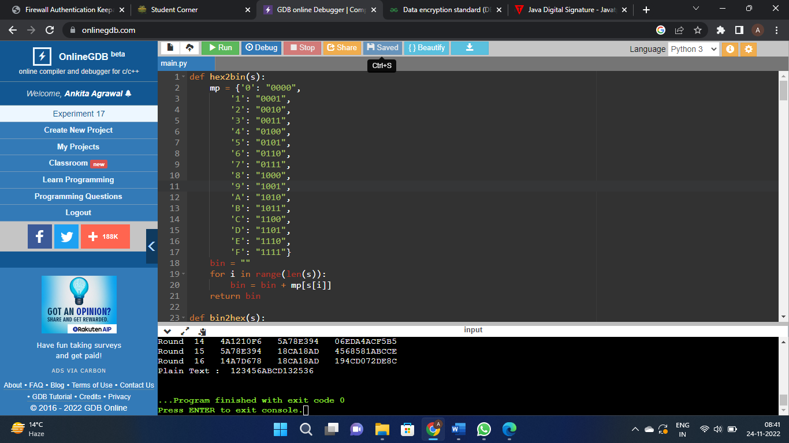

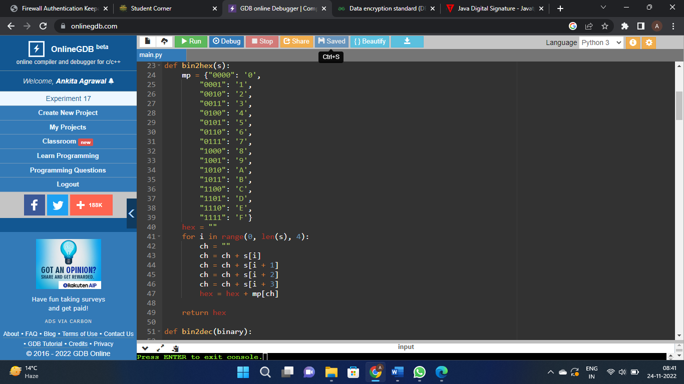

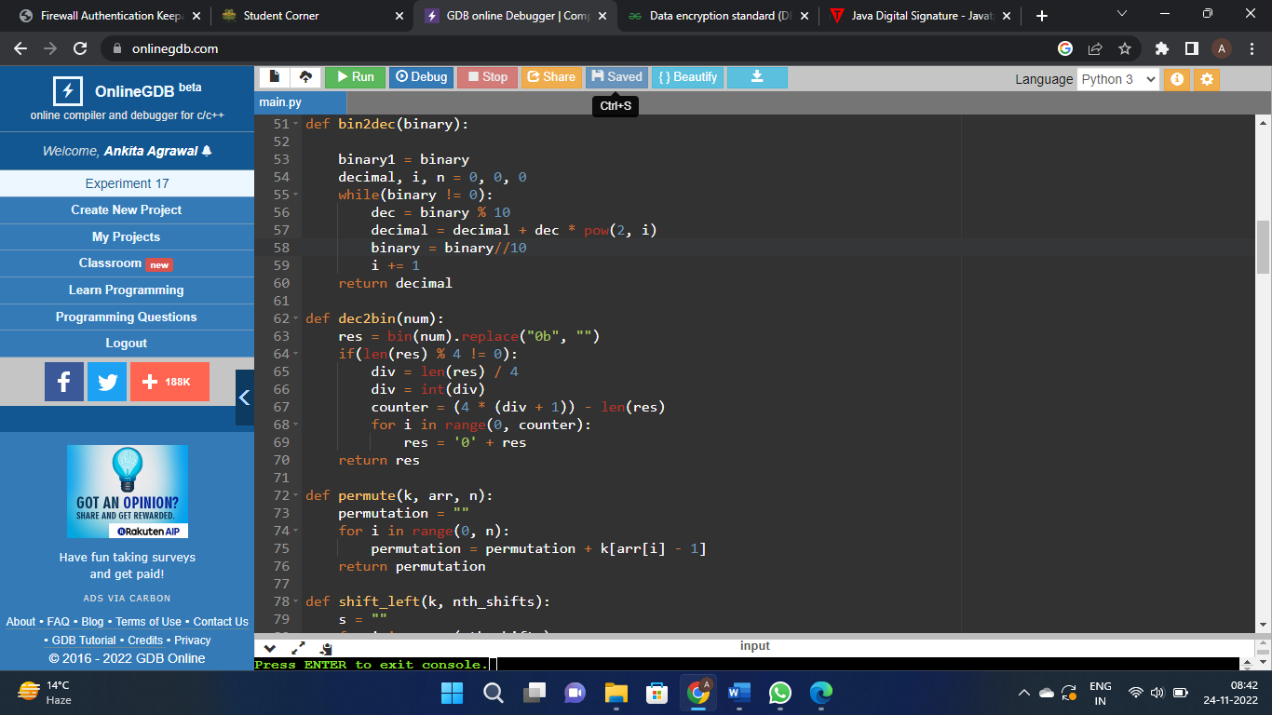

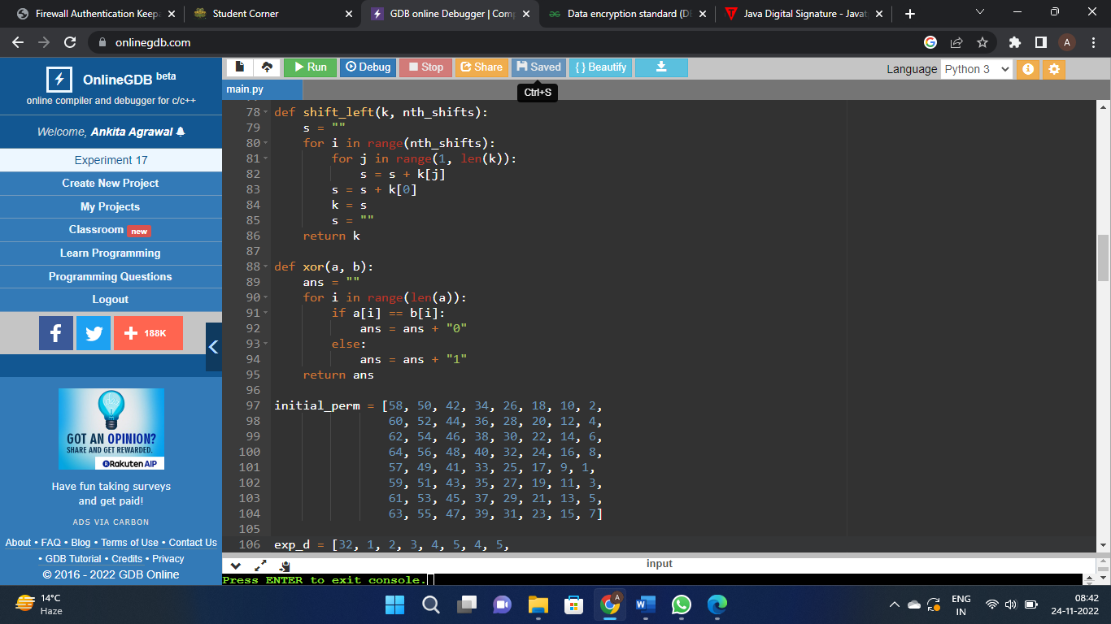

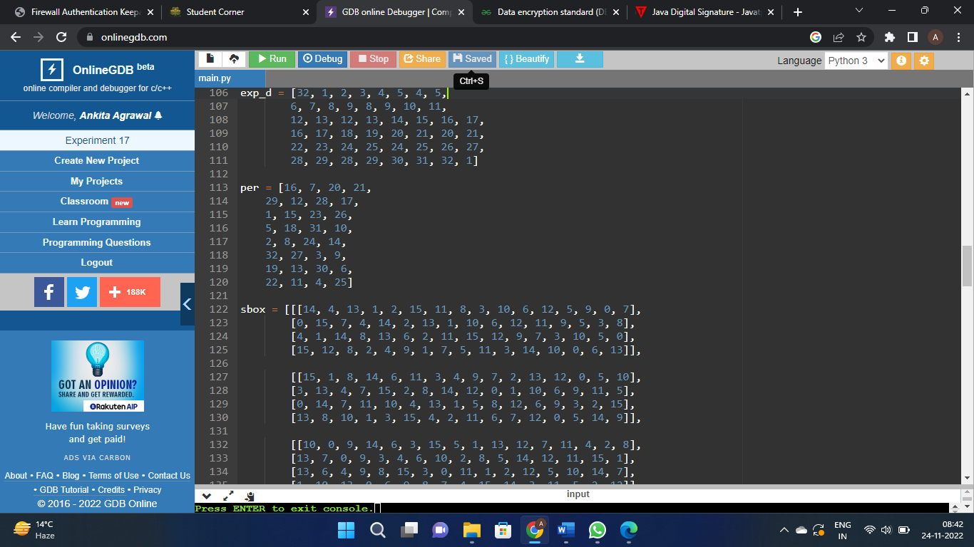

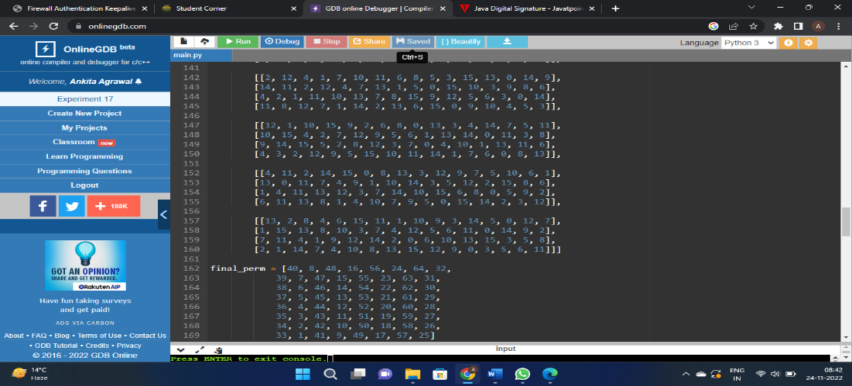

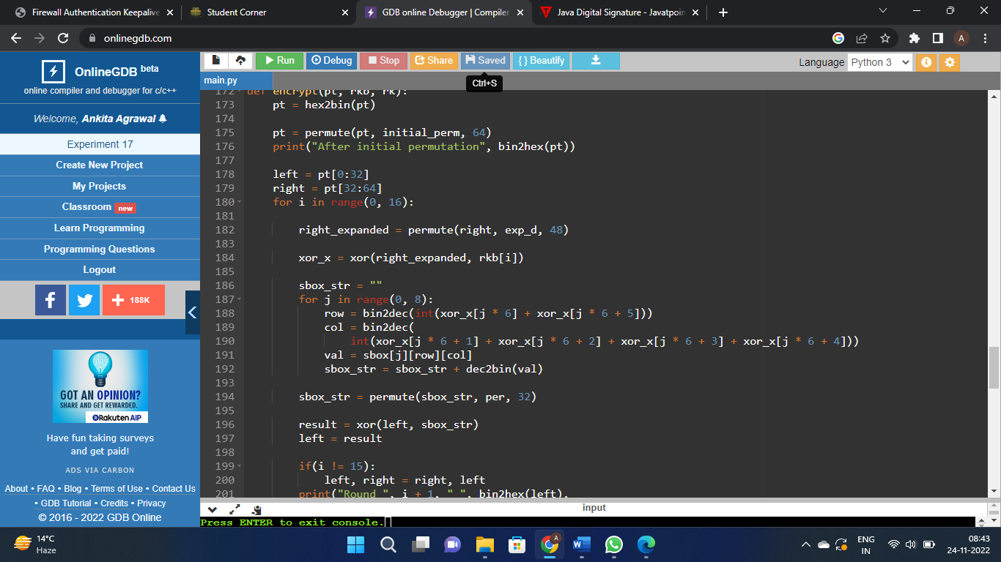

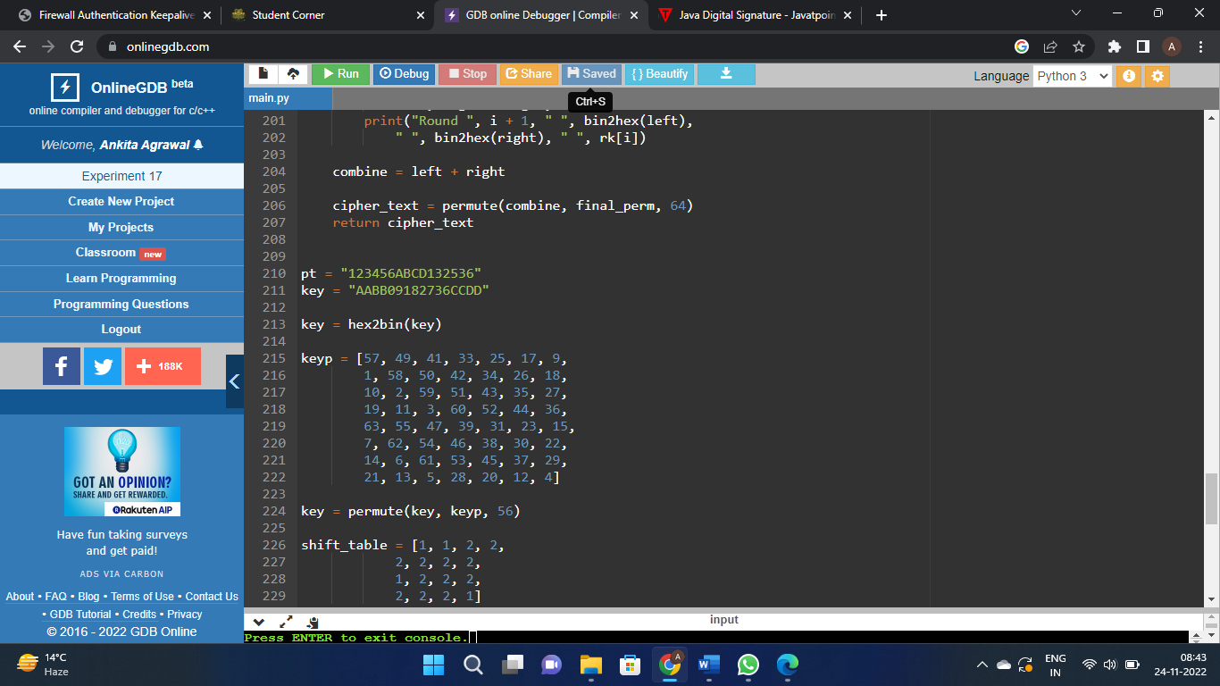

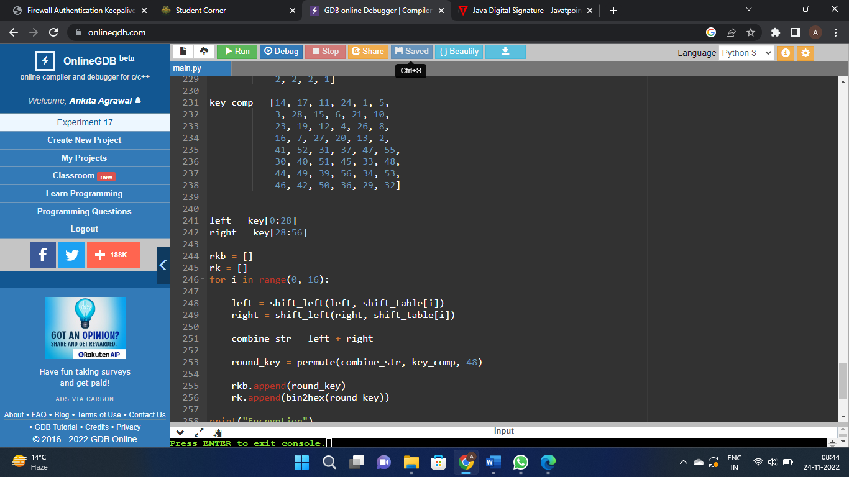

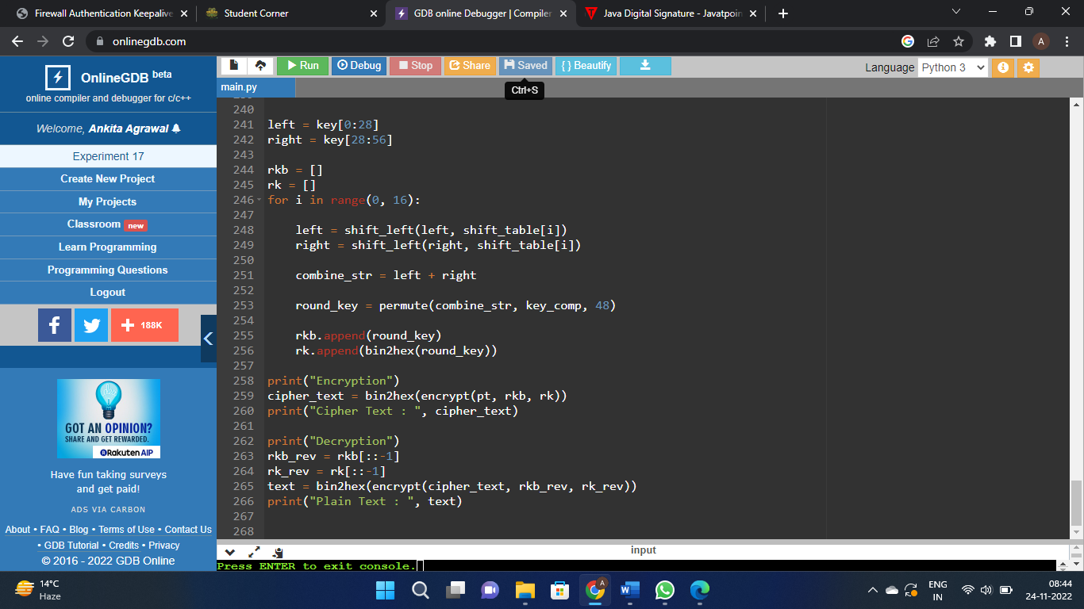

1. W.A.P. to implement RSA Algorithm to generate a pair of keys and show the encryption and decryption by using a given key pair.

Code:

import math

def gcd(a, h):

temp = 0

while(1):

temp = a % h

if (temp == 0):

return h

a = h

h = temp

p = 3

q = 7

n = p*q

e = 2

phi = (p-1)*(q-1)

while (e < phi):

if(gcd(e, phi) == 1):

break

else:

e = e+1

k = 2

d = (1 + (k*phi))/e

msg = 12.0

print("Message data = ", msg)

c = pow(msg, e)

c = math.fmod(c, n)

print("Encrypted data = ", c)

m = pow(c, d)

m = math.fmod(m, n)

print("Original Message Sent = ", m)

ScreenShot:

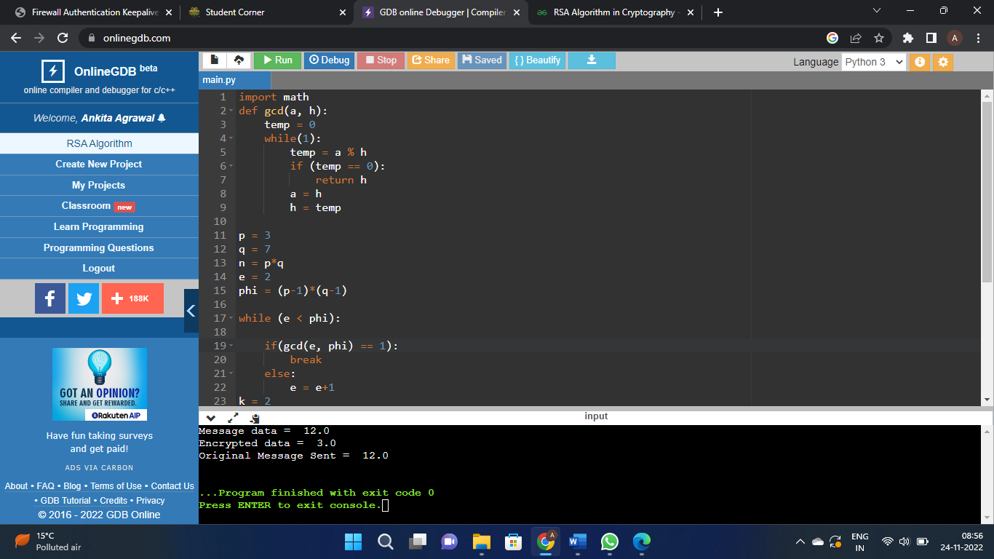

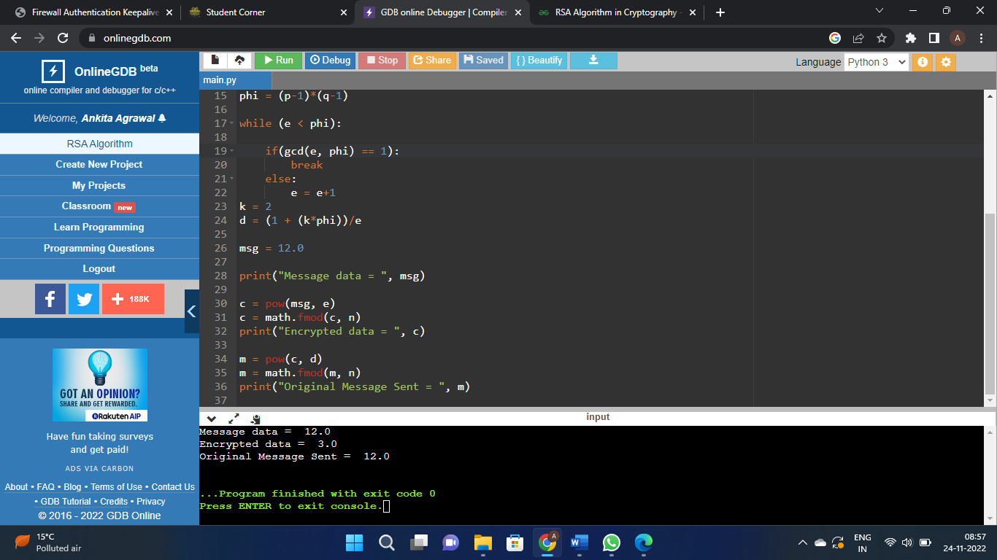

1. W.A.P. to implement RSA Algorithm for implementing digital signature.

Code:

def euclid(m, n):

if n == 0:

return m

else:

r = m % n

return euclid(n, r)

def exteuclid(a, b):

r1 = a

r2 = b

s1 = int(1)

s2 = int(0)

t1 = int(0)

t2 = int(1)

while r2 > 0:

q = r1//r2

r = r1-q * r2

r1 = r2

r2 = r

s = s1-q * s2

s1 = s2

s2 = s

t = t1-q * t2

t1 = t2

t2 = t

if t1 < 0:

t1 = t1 % a

return (r1, t1)

p = 823

q = 953

n = p * q

Pn = (p-1)*(q-1)

key = []

for i in range(2, Pn):

gcd = euclid(Pn, i)

if gcd == 1:

key.append(i)

e = int(313)

r, d = exteuclid(Pn, e)

if r == 1:

d = int(d)

print("decryption key is: ", d)

else:

print("Multiplicative inverse for\

the given encryption key does not \

exist. Choose a different encryption key ")

M = 19070

S = (M**d) % n

M1 = (S**e) % n

if M == M1:

print("As M = M1, Accept the\

message sent by Alice")

else:

print("As M not equal to M1,\

Do not accept the message\

sent by Alice ")

ScreenShot:

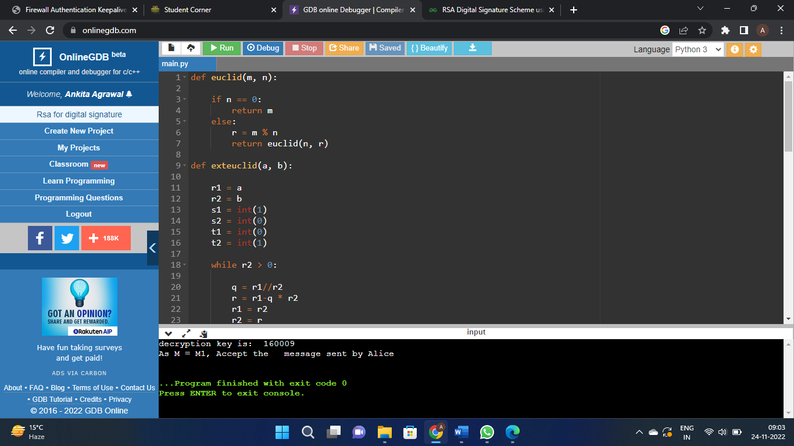

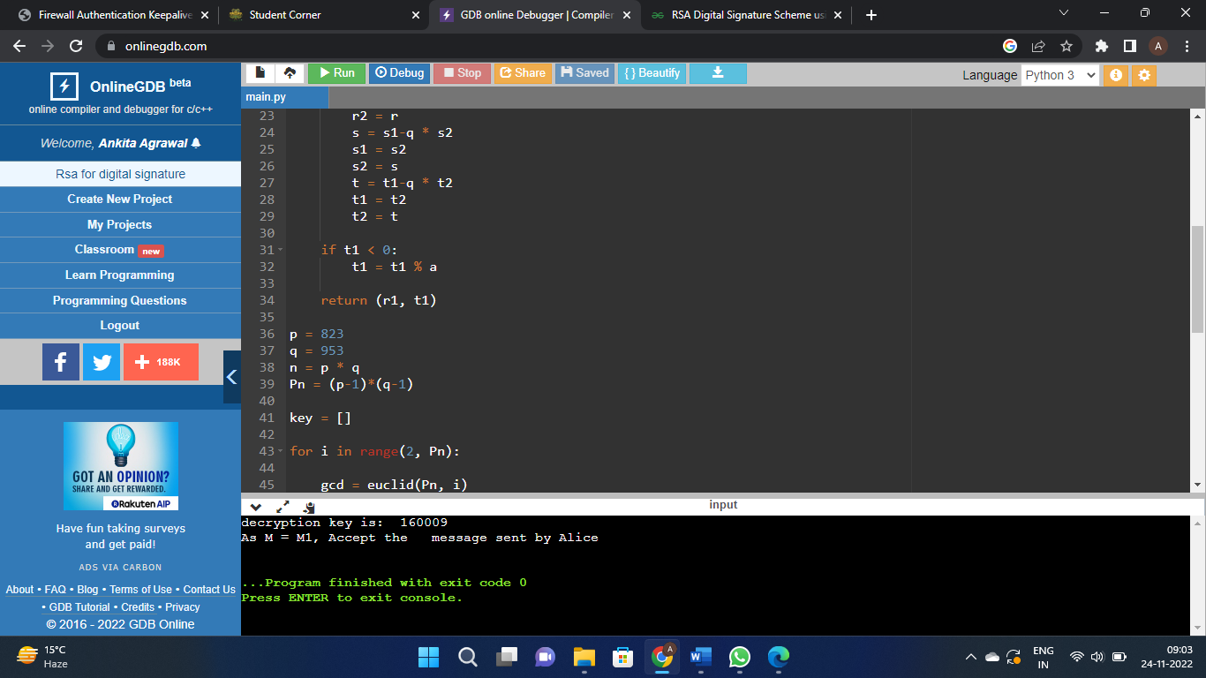

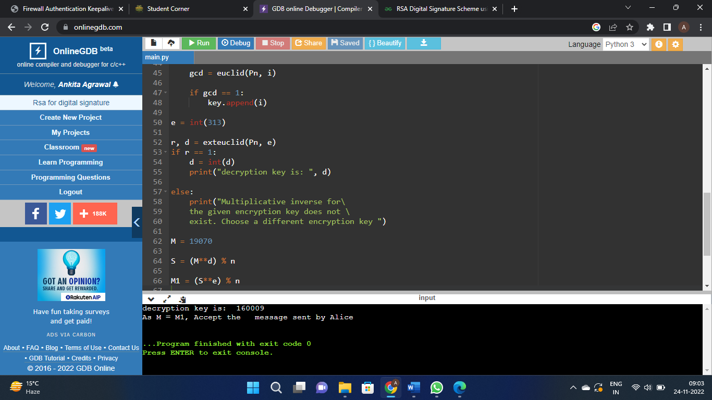

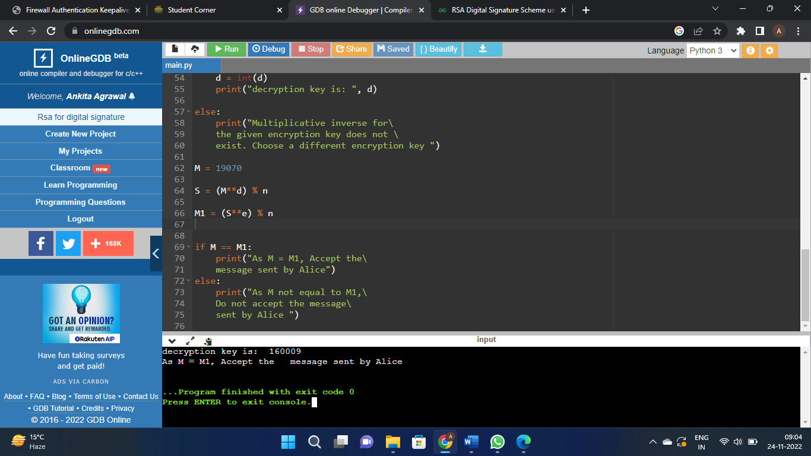

1. W.A.P. to implement Elgamal algorithm for implementing digital signature.

Code:

import random

from math import pow

a = random.randint(2, 10)

def gcd(a, b):

if a < b:

return gcd(b, a)

elif a % b == 0:

return b;

else:

return gcd(b, a % b)

\

def gen_key(q):

key = random.randint(pow(10, 20), q)

while gcd(q, key) != 1:

key = random.randint(pow(10, 20), q)

return key

def power(a, b, c):

x = 1

y = a

while b > 0:

if b % 2 != 0:

x = (x * y) % c;

y = (y * y) % c

b = int(b / 2)

return x % c

def encrypt(msg, q, h, g):

en_msg = []

k = gen_key(q)

s = power(h, k, q)

p = power(g, k, q)

for i in range(0, len(msg)):

en_msg.append(msg[i])

print("g^k used : ", p)

print("g^ak used : ", s)

for i in range(0, len(en_msg)):

en_msg[i] = s * ord(en_msg[i])

return en_msg, p

def decrypt(en_msg, p, key, q):

dr_msg = []

h = power(p, key, q)

for i in range(0, len(en_msg)):

dr_msg.append(chr(int(en_msg[i]/h)))

return dr_msg

def main():

msg = 'encryption'

print("Original Message :", msg)

q = random.randint(pow(10, 20), pow(10, 50))

g = random.randint(2, q)

key = gen_key(q)# Private key for receiver

h = power(g, key, q)

print("g used : ", g)

print("g^a used : ", h)

en_msg, p = encrypt(msg, q, h, g)

dr_msg = decrypt(en_msg, p, key, q)

dmsg = ''.join(dr_msg)

print("Decrypted Message :", dmsg);

if __name__ == '__main__':

main()

ScreenShot:

